# Core ML Basics to Advanced

May 28, 2024

teach me core ML from basics to advance full in detail with examples and codes

To teach you core Machine Learning (ML) from basics to advanced with examples and code, we'll cover the following topics in a structured manner. This will include:

1. **Introduction to Machine Learning**
2. **Data Preprocessing**
3. **Supervised Learning**
   * Linear Regression
   * Logistic Regression
   * Support Vector Machines (SVM)
   * Decision Trees and Random Forests
   * k-Nearest Neighbors (k-NN)
   * Neural Networks
4. **Unsupervised Learning**
   * Clustering (k-Means, Hierarchical)
   * Dimensionality Reduction (PCA, t-SNE)
5. **Reinforcement Learning**
6. **Model Evaluation and Selection**
7. **Advanced Topics**
   * Ensemble Methods (Boosting, Bagging)
   * Deep Learning
   * Natural Language Processing (NLP)
   * Time Series Analysis

Let's break this down into a mind map for better organization and clarity.

### Title: Core Machine Learning

* **Introduction to Machine Learning**
  + What is Machine Learning?
  + Types of Machine Learning
    - Supervised Learning
    - Unsupervised Learning
    - Reinforcement Learning
* **Data Preprocessing**
  + Data Cleaning
  + Feature Scaling
  + Encoding Categorical Data
  + Splitting Data into Training and Test Sets
* **Supervised Learning**
  + **Linear Regression**
    - Simple Linear Regression
    - Multiple Linear Regression
    - Example and Code
  + **Logistic Regression**
    - Binary Classification
    - Multiclass Classification
    - Example and Code
  + **Support Vector Machines (SVM)**
    - Concept of Hyperplane
    - Kernel Trick
    - Example and Code
  + **Decision Trees and Random Forests**
    - Decision Tree Construction
    - Random Forest Ensemble
    - Example and Code
  + **k-Nearest Neighbors (k-NN)**
    - Distance Metrics
    - Example and Code
  + **Neural Networks**
    - Perceptron and Multilayer Perceptrons
    - Backpropagation
    - Example and Code
* **Unsupervised Learning**
  + **Clustering**
    - k-Means Clustering
    - Hierarchical Clustering
    - Example and Code
  + **Dimensionality Reduction**
    - Principal Component Analysis (PCA)
    - t-Distributed Stochastic Neighbor Embedding (t-SNE)
    - Example and Code
* **Reinforcement Learning**
  + Q-Learning
  + Deep Q-Networks
  + Example and Code
* **Model Evaluation and Selection**
  + Cross-Validation
  + Grid Search
  + Metrics (Accuracy, Precision, Recall, F1-Score)
* **Advanced Topics**
  + **Ensemble Methods**
    - Boosting (AdaBoost, Gradient Boosting)
    - Bagging
    - Example and Code
  + **Deep Learning**
    - Convolutional Neural Networks (CNNs)
    - Recurrent Neural Networks (RNNs)
    - Example and Code
  + **Natural Language Processing (NLP)**
    - Text Preprocessing
    - Sentiment Analysis
    - Example and Code
  + **Time Series Analysis**
    - ARIMA Models
    - Long Short-Term Memory Networks (LSTMs)
    - Example and CodeI'll generate a mind map for this structure.
* Here is the mind map for Core Machine Learning from basics to advanced:
  + - 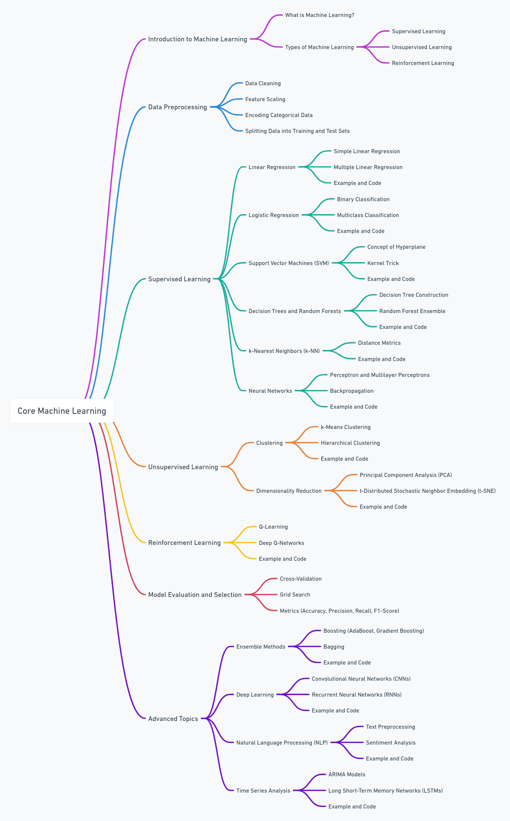

### Detailed Breakdown with Examples and Code

Now, let's delve into each topic with detailed explanations, examples, and code.

#### 1. Introduction to Machine Learning

**What is Machine Learning?** Machine Learning (ML) is a subset of artificial intelligence (AI) that involves the use of algorithms and statistical models to enable computers to improve their performance on a task through experience. It involves training a model on data to make predictions or decisions without being explicitly programmed for the task.

**Types of Machine Learning:**

* **Supervised Learning:** Learning from labeled data to make predictions.
* **Unsupervised Learning:** Finding patterns and relationships in unlabeled data.
* **Reinforcement Learning:** Learning through rewards and penalties to achieve a goal.

#### 2. Data Preprocessing

**Data Cleaning:**

* Handling missing values
* Removing duplicates
* Correcting errors

**Feature Scaling:**

python

Copy code

from sklearn.preprocessing import StandardScaler

scaler = StandardScaler()

scaled_data = scaler.fit_transform(data)

**Encoding Categorical Data:**

python

Copy code

from sklearn.preprocessing import OneHotEncoder

encoder = OneHotEncoder()

encoded_data = encoder.fit_transform(data)

**Splitting Data into Training and Test Sets:**

python

Copy code

from sklearn.model_selection import train_test_split

X_train, X_test, y_train, y_test = train_test_split(X, y, test_size=0.2, random_state=42)

#### 3. Supervised Learning

**Linear Regression:**

python

Copy code

from sklearn.linear_model import LinearRegression

model = LinearRegression()

model.fit(X_train, y_train)

predictions = model.predict(X_test)

**Logistic Regression:**

python

Copy code

from sklearn.linear_model import LogisticRegression

model = LogisticRegression()

model.fit(X_train, y_train)

predictions = model.predict(X_test)

**Support Vector Machines (SVM):**

python

Copy code

from sklearn.svm import SVC

model = SVC(kernel='linear')

model.fit(X_train, y_train)

predictions = model.predict(X_test)

**Decision Trees and Random Forests:**

python

Copy code

from sklearn.tree import DecisionTreeClassifier

model = DecisionTreeClassifier()

model.fit(X_train, y_train)

predictions = model.predict(X_test)

from sklearn.ensemble import RandomForestClassifier

model = RandomForestClassifier(n_estimators=100)

model.fit(X_train, y_train)

predictions = model.predict(X_test)

**k-Nearest Neighbors (k-NN):**

python

Copy code

from sklearn.neighbors import KNeighborsClassifier

model = KNeighborsClassifier(n_neighbors=5)

model.fit(X_train, y_train)

predictions = model.predict(X_test)

**Neural Networks:**

python

Copy code

from sklearn.neural_network import MLPClassifier

model = MLPClassifier(hidden_layer_sizes=(100,))

model.fit(X_train, y_train)

predictions = model.predict(X_test)

#### 4. Unsupervised Learning

**k-Means Clustering:**

python

Copy code

from sklearn.cluster import KMeans

model = KMeans(n_clusters=3)

model.fit(data)

clusters = model.predict(data)

**Dimensionality Reduction (PCA):**

python

Copy code

from sklearn.decomposition import PCA

pca = PCA(n_components=2)

reduced_data = pca.fit_transform(data)

#### 5. Reinforcement Learning

**Q-Learning:**

python

Copy code

import numpy as np

# Simple Q-learning example

states = [0, 1, 2, 3]

actions = [0, 1]

Q = np.zeros((len(states), len(actions)))

for episode in range(1000):

state = np.random.choice(states)

while state != 3: # Terminal state

action = np.random.choice(actions)

next_state = np.random.choice(states)

reward = 1 if next_state == 3 else 0

Q[state, action] = Q[state, action] + 0.1 * (reward + 0.9 * np.max(Q[next_state, :]) - Q[state, action])

state = next_state

#### 6. Model Evaluation and Selection

**Cross-Validation:**

python

Copy code

from sklearn.model_selection import cross_val_score

scores = cross_val_score(model, X, y, cv=5)

**Grid Search:**

python

Copy code

from sklearn.model_selection import GridSearchCV

param_grid = {'C': [0.1, 1, 10]}

grid_search = GridSearchCV(SVC(), param_grid, cv=5)

grid_search.fit(X_train, y_train)

**Metrics (Accuracy, Precision, Recall, F1-Score):**

python

Copy code

from sklearn.metrics import accuracy_score, precision_score, recall_score, f1_score

accuracy = accuracy_score(y_test, predictions)

precision = precision_score(y_test, predictions)

recall = recall_score(y_test, predictions)

f1 = f1_score(y_test, predictions)

#### 7. Advanced Topics

**Ensemble Methods (Boosting):**

python

Copy code

from sklearn.ensemble import AdaBoostClassifier

model = AdaBoostClassifier(n_estimators=100)

model.fit(X_train, y_train)

predictions = model.predict(X_test)

**Deep Learning (CNNs):**

python

Copy code

from tensorflow.keras.models import Sequential

from tensorflow.keras.layers import Conv2D, MaxPooling2D, Flatten, Dense

model = Sequential([

Conv2D(32, (3, 3), activation='relu', input_shape=(28, 28, 1)),

MaxPooling2D((2, 2)),

Flatten(),

Dense(128, activation='relu'),

Dense(10, activation='softmax')

])

model.compile(optimizer='adam', loss='sparse_categorical_crossentropy', metrics=['accuracy'])

model.fit(X_train, y_train, epochs=10)

**Natural Language Processing (NLP):**

python

Copy code

from sklearn.feature_extraction.text import CountVectorizer

vectorizer = CountVectorizer()

X = vectorizer.fit_transform(text_data)

**Time Series Analysis (ARIMA):**

python

Copy code

from statsmodels.tsa.arima.model import ARIMA

model = ARIMA(time_series_data, order=(5, 1, 0))

model_fit = model.fit()

predictions = model_fit.forecast(steps=10)

This comprehensive guide covers the core concepts of Machine Learning, along with examples and code snippets to help you understand and implement these techniques. Feel free to explore each section in more detail and practice with real datasets to solidify your understanding.

To teach you scikit-learn (sklearn) with diagrams in an easy way, I'll cover the following key topics and use diagrams to illustrate the processes:

1. **Introduction to scikit-learn**
2. **Data Preprocessing with scikit-learn**
3. **Training and Evaluating Models**
4. **Cross-Validation and Hyperparameter Tuning**
5. **Saving and Loading Models**

We'll use a combination of flowcharts and sequence diagrams to explain these concepts.

### 1. Introduction to scikit-learn

Scikit-learn is a popular machine learning library in Python that provides simple and efficient tools for data mining and data analysis. It is built on NumPy, SciPy, and Matplotlib.

### 2. Data Preprocessing with scikit-learn

Data preprocessing includes steps such as handling missing values, encoding categorical data, and scaling features. Let's create a flowchart to visualize these steps.

#### Flowchart: Data Preprocessing Steps

mermaid

Copy code

graph TD

A[Start] --> B[Load Dataset]

B --> C[Handle Missing Values]

C --> D[Encode Categorical Data]

D --> E[Scale Features]

E --> F[Split Data into Training and Test Sets]

F --> G[End]

### 3. Training and Evaluating Models

The typical workflow involves choosing a model, training it on the training data, making predictions on the test data, and evaluating its performance.

#### Sequence Diagram: Model Training and Evaluation

plaintext

Copy code

Participant User -> Participant Dataset: Load Data

Participant User -> Participant Preprocessing: Preprocess Data

Participant Preprocessing -> Participant Model: Train Model

Participant User -> Participant Model: Make Predictions

Participant User -> Participant Evaluation: Evaluate Model

### 4. Cross-Validation and Hyperparameter Tuning

Cross-validation is used to assess the generalizability of the model, and hyperparameter tuning helps in finding the best parameters for the model.

#### Flowchart: Cross-Validation and Hyperparameter Tuning

mermaid

Copy code

graph TD

A[Start] --> B[Load Dataset]

B --> C[Preprocess Data]

C --> D[Define Model]

D --> E[Cross-Validation]

E --> F[Hyperparameter Tuning]

F --> G[Train Final Model]

G --> H[Evaluate Final Model]

H --> I[End]

### 5. Saving and Loading Models

Once a model is trained and evaluated, it can be saved for future use and loaded later.

#### Sequence Diagram: Saving and Loading Models

plaintext

Copy code

Participant User -> Participant Model: Train Model

Participant User -> Participant Model: Save Model

Participant User -> Participant Storage: Store Model

Participant User -> Participant Storage: Load Model

Participant User -> Participant Model: Use Model for Predictions

### Detailed Steps with Code

Now, let's go through each step with corresponding code examples in Python using scikit-learn.

#### 1. Data Preprocessing

**Loading the Dataset:**

python

Copy code

from sklearn.datasets import load_iris

import pandas as pd

data = load_iris()

df = pd.DataFrame(data.data, columns=data.feature_names)

df['target'] = data.target

**Handling Missing Values:**

python

Copy code

df.fillna(df.mean(), inplace=True)

**Encoding Categorical Data:**

python

Copy code

from sklearn.preprocessing import LabelEncoder

label_encoder = LabelEncoder()

df['target'] = label_encoder.fit_transform(df['target'])

**Scaling Features:**

python

Copy code

from sklearn.preprocessing import StandardScaler

scaler = StandardScaler()

df_scaled = pd.DataFrame(scaler.fit_transform(df.iloc[:, :-1]), columns=df.columns[:-1])

df_scaled['target'] = df['target']

**Splitting Data into Training and Test Sets:**

python

Copy code

from sklearn.model_selection import train_test_split

X = df_scaled.drop('target', axis=1)

y = df_scaled['target']

X_train, X_test, y_train, y_test = train_test_split(X, y, test_size=0.2, random_state=42)

#### 2. Training and Evaluating Models

**Training a Model:**

python

Copy code

from sklearn.linear_model import LogisticRegression

model = LogisticRegression()

model.fit(X_train, y_train)

**Making Predictions:**

python

Copy code

predictions = model.predict(X_test)

**Evaluating the Model:**

python

Copy code

from sklearn.metrics import accuracy_score, classification_report

accuracy = accuracy_score(y_test, predictions)

report = classification_report(y_test, predictions)

print(f"Accuracy: {accuracy}")

print(f"Classification Report:\n{report}")

#### 3. Cross-Validation and Hyperparameter Tuning

**Cross-Validation:**

python

Copy code

from sklearn.model_selection import cross_val_score

scores = cross_val_score(model, X, y, cv=5)

print(f"Cross-Validation Scores: {scores}")

**Hyperparameter Tuning with Grid Search:**

python

Copy code

from sklearn.model_selection import GridSearchCV

param_grid = {'C': [0.1, 1, 10], 'solver': ['lbfgs', 'liblinear']}

grid_search = GridSearchCV(LogisticRegression(), param_grid, cv=5)

grid_search.fit(X_train, y_train)

print(f"Best Parameters: {grid_search.best_params_}")

best_model = grid_search.best_estimator_

#### 4. Saving and Loading Models

**Saving the Model:**

python

Copy code

import joblib

joblib.dump(model, 'logistic_regression_model.pkl')

**Loading the Model:**

python

Copy code

loaded_model = joblib.load('logistic_regression_model.pkl')

predictions = loaded_model.predict(X_test)

These examples cover the basic workflow of using scikit-learn for machine learning tasks. The diagrams provide a visual understanding of the processes, while the code snippets offer practical

**Ensemble Learning:**

Ensemble learning is a machine learning technique that combines the predictions of multiple models to improve the overall performance and accuracy of the final prediction. The idea is that by combining the strengths of several models, the ensemble can achieve better results than any single model.

**Types of Ensemble:**

LearningEnsemble learning is a machine learning technique that combines the predictions of multiple models to improve the overall performance and accuracy of the final prediction. The idea is that by combining the strengths of several models, the ensemble can achieve better results than any single model.

Types of Ensemble Learning

Bagging (Bootstrap Aggregating)

Example: Random Forest

Usage: Reduces variance and helps in improving the accuracy of weak learners.

Boosting

Example: AdaBoost, Gradient Boosting Machines (GBM), XGBoost

Usage: Reduces bias by focusing on hard-to-predict instances, gradually improving the model's performance.

Stacking (Stacked Generalization)

Example: Stacked Regressor, Stacked Classifier

Usage: Combines multiple models (base-level models) using a meta-model, which learns how to best combine the predictions from the base models.

Voting

Example: Majority Voting Classifier

Usage: Combines the predictions of multiple models by voting, using either hard voting (majority vote) or soft voting (weighted average of probabilities).

Diagrams for Ensemble Learning

Mind Map: Ensemble Learning Overview

This mind map will summarize the key components and examples of ensemble learning.

markdown

Copy code

Title: Ensemble Learning

- Definition

- Combines multiple models

- Improves performance

- Types

- Bagging

- Example: Random Forest

- Usage: Reduces variance

- Boosting

- Example: AdaBoost, GBM, XGBoost

- Usage: Reduces bias

- Stacking

- Example: Stacked Regressor, Stacked Classifier

- Usage: Combines base models with meta-model

- Voting

- Example: Majority Voting Classifier

- Usage: Combines predictions by voting

Flowchart: Bagging (Random Forest) Process

This flowchart will visualize the process of Bagging using Random Forest as an example.

mermaid

Copy code

graph TD

A[Start] --> B[Create Multiple Subsets of Data]

B --> C[Train Each Subset with a Base Model (e.g., Decision Tree)]

C --> D[Combine Predictions Using Majority Voting or Averaging]

D --> E[Final Prediction]

E --> F[End]

Sequence Diagram: Boosting (AdaBoost) Process

This sequence diagram will illustrate the boosting process using AdaBoost as an example.

mermaid

Copy code

sequenceDiagram

Participant TrainingData

Participant WeakLearner1

Participant WeakLearner2

Participant WeakLearnerN

Participant FinalModel

TrainingData -> WeakLearner1: Train on initial data

WeakLearner1 -> FinalModel: Provide weak prediction

TrainingData -> WeakLearner2: Train on reweighted data

WeakLearner2 -> FinalModel: Provide weak prediction

TrainingData -> WeakLearnerN: Train on reweighted data

WeakLearnerN -> FinalModel: Provide weak prediction

FinalModel -> FinalModel: Combine weak predictions into strong prediction

Let's generate these diagrams.

Generating Mind Map: Ensemble Learning Overview

I'll generate the mind map first.

Talked to whimsical.com

Mind Map: Ensemble Learning Overview

Ensemble Learning Overview

Diagrams for Ensemble Learning

Mind Map: Ensemble Learning Overview

This mind map will summarize the key components and examples of ensemble learning.

markdown

Copy code

Title: Ensemble Learning - Definition - Combines multiple models - Improves performance - Types –

* Bagging - Example: Random Forest - Usage: Reduces variance
* Boosting - Example: AdaBoost, GBM, XGBoost - Usage: Reduces bias
* Stacking - Example: Stacked Regressor, Stacked Classifier - Usage: Combines base models with meta-model
* Voting - Example: Majority Voting Classifier - Usage: Combines predictions by voting

Flowchart: Bagging (Random Forest) Process

This flowchart will visualize the process of Bagging using Random Forest as an example.

mermaid

Copy code

graph TD A[Start] --> B[Create Multiple Subsets of Data] B --> C[Train Each Subset with a Base Model (e.g., Decision Tree)] C --> D[Combine Predictions Using Majority Voting or Averaging] D --> E[Final Prediction] E --> F[End]

Sequence Diagram: Boosting (AdaBoost) Process

This sequence diagram will illustrate the boosting process using AdaBoost as an example.

mermaid

Copy code

sequenceDiagram Participant TrainingData Participant WeakLearner1 Participant WeakLearner2 Participant WeakLearnerN Participant FinalModel TrainingData -> WeakLearner1: Train on initial data WeakLearner1 -> FinalModel: Provide weak prediction TrainingData -> WeakLearner2: Train on reweighted data WeakLearner2 -> FinalModel: Provide weak prediction TrainingData -> WeakLearnerN: Train on reweighted data WeakLearnerN -> FinalModel: Provide weak prediction FinalModel -> FinalModel: Combine weak predictions into strong prediction

Let's generate these diagrams. Ensemble learning is a machine learning technique that combines the predictions of multiple models to improve the overall performance and accuracy of the final prediction. The idea is that by combining the strengths of several models, the ensemble can achieve better results than any single model.

Types of Ensemble Learning

Bagging (Bootstrap Aggregating)

Example: Random Forest

Usage: Reduces variance and helps in improving the accuracy of weak learners.

Boosting

Example: AdaBoost, Gradient Boosting Machines (GBM), XGBoost

Usage: Reduces bias by focusing on hard-to-predict instances, gradually improving the model's performance.

Stacking (Stacked Generalization)

Example: Stacked Regressor, Stacked Classifier

Usage: Combines multiple models (base-level models) using a meta-model, which learns how to best combine the predictions from the base models.

Voting

Example: Majority Voting Classifier

Usage: Combines the predictions of multiple models by voting, using either hard voting (majority vote) or soft voting (weighted average of probabilities).

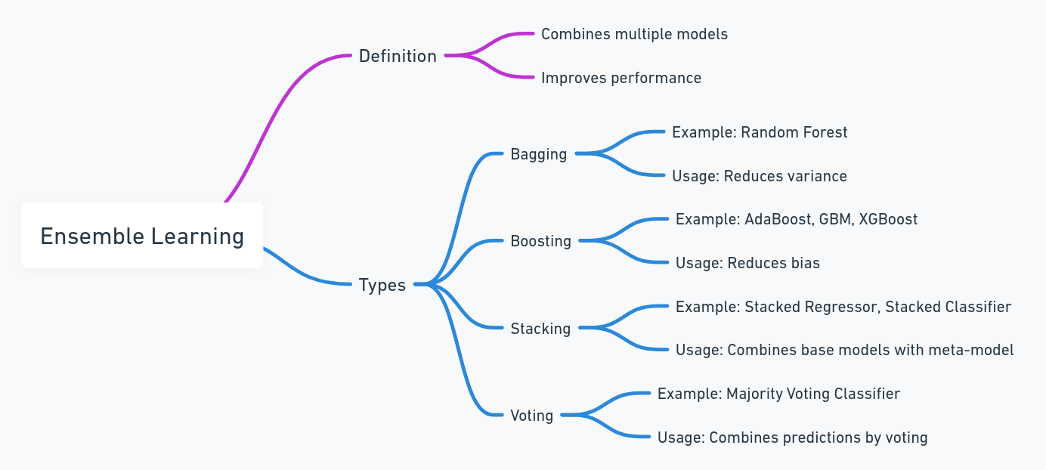

**EVALUATING REGRESSION METRICS:**

**Evaluating regression models involves several key metrics that help assess the performance of the models. Here are the primary evaluation metrics for regression models:**

1. **Mean Absolute Error (MAE)**
2. **Mean Squared Error (MSE)**
3. **Root Mean Squared Error (RMSE)**
4. **R-squared (R²)**

**Mean Absolute Error (MAE)**

**Formula: MAE = (1/n) * sum(|y_i - ŷ_i|)]**

* **𝑦^𝑖 = Predicted values**
* **𝑛 = Number of observations**

**Mean Squared Error (MSE)**

**Formula: MSE = (1/n) * sum((y_i - ŷ_i)^2)]**

**Root Mean Squared Error (RMSE)**

**Formula: RMSE = sqrt((1/n) * sum((y_i - ŷ_i)^2))]**

**R-squared (R²)**

**Formula: R² = 1 - (sum((y_i - ŷ_i)^2) / sum((y_i - ȳ)^2))]**

**Where:**

* ***y*ˉ​ = Mean of the actual values**

**Adjusted R-squared (Adjusted R²)**

**Adjusted R-squared is a modified version of R-squared that has been adjusted for the number of predictors in the model. It is used to determine how well the model generalizes and prevents overfitting by penalizing the addition of unnecessary predictors.**

**Formula: Adjusted R² = 1 - ((1 - R²)/(n - p - 1)) * (n - 1)]**

**Where:**

* **𝑅2 = R-squared**
* **𝑛 = Number of observations**
* **𝑝 = Number of predictors**

**L1 and L2 Regularizations techniques:**

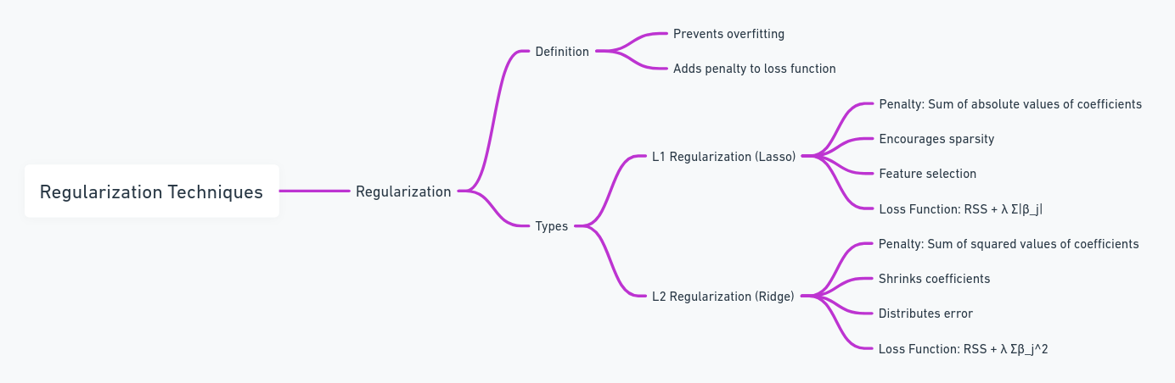

**CLASSIFICATION**

### Logistic Regression

**Concept:** Logistic regression is a statistical method used for binary classification. It predicts the probability that a given input belongs to a certain category.

**Example:** Imagine you are a lemon farmer trying to predict whether a lemon is ripe (1) or not ripe (0). You have data on the size and color of the lemons.

**Steps:**

1. **Data Collection:** Collect data on the size and color of lemons along with their ripeness.
2. **Model Training:** Use this data to train a logistic regression model, which will learn the relationship between the size and color of lemons and their ripeness.
3. **Prediction:** For a new lemon, input its size and color into the model to get the probability of it being ripe.

**Formula:**

**Steps to build a logistic regression model:**

1. **Collect Data:** Gather data on the size and color of lemons and their ripeness.
2. **Train the Model:** Use the collected data to estimate the coefficients (β\betaβ) by maximizing the likelihood of observing the given data.
3. **Make Predictions:** For a new lemon, use the model to calculate the probability of it being ripe.

**Decision Boundary:** The decision boundary is the value at which the predicted probability is 0.5. Lemons with probabilities above 0.5 are classified as ripe, while those below 0.5 are classified as not ripe.

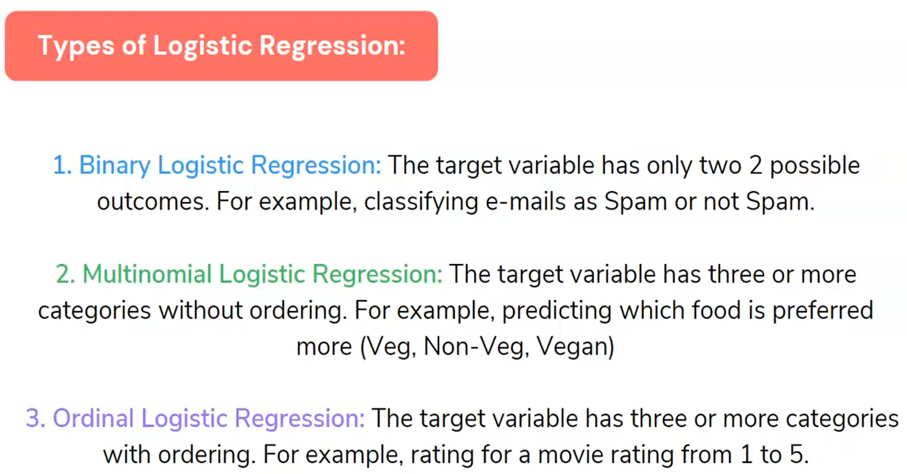

### K-Nearest Neighbors (KNN) Classification

**Concept:** KNN is a simple, non-parametric algorithm used for classification. It classifies a new data point based on the majority class among its k-nearest neighbors.

**Example:** Let's say you want to classify a lemon as ripe or not ripe based on its size and color. You already have a dataset of labeled lemons.

**Steps:**

1. **Data Collection:** Collect data on the size and color of lemons along with their ripeness.
2. **Distance Calculation:** For a new lemon, calculate the distance between this lemon and all other lemons in your dataset.
3. **Find Neighbors:** Identify the k-nearest neighbors (lemons) to the new lemon.
4. **Majority Voting:** The new lemon is classified based on the majority class (ripe or not ripe) among its nearest neighbors.

KNN does not have a specific formula but uses the distance between points to classify new data.

**Steps to classify using KNN:**

1. **Choose k:** Decide on the number of nearest neighbors to consider (e.g., k=3).
2. **Calculate Distance:** Use a distance metric (e.g., Euclidean distance) to calculate the distance between the new data point and all other points in the dataset.
3. **Identify Neighbors:** Find the k-nearest neighbors to the new data point.
4. **Majority Voting:** Assign the class label to the new data point based on the majority class among its k-nearest neighbors.

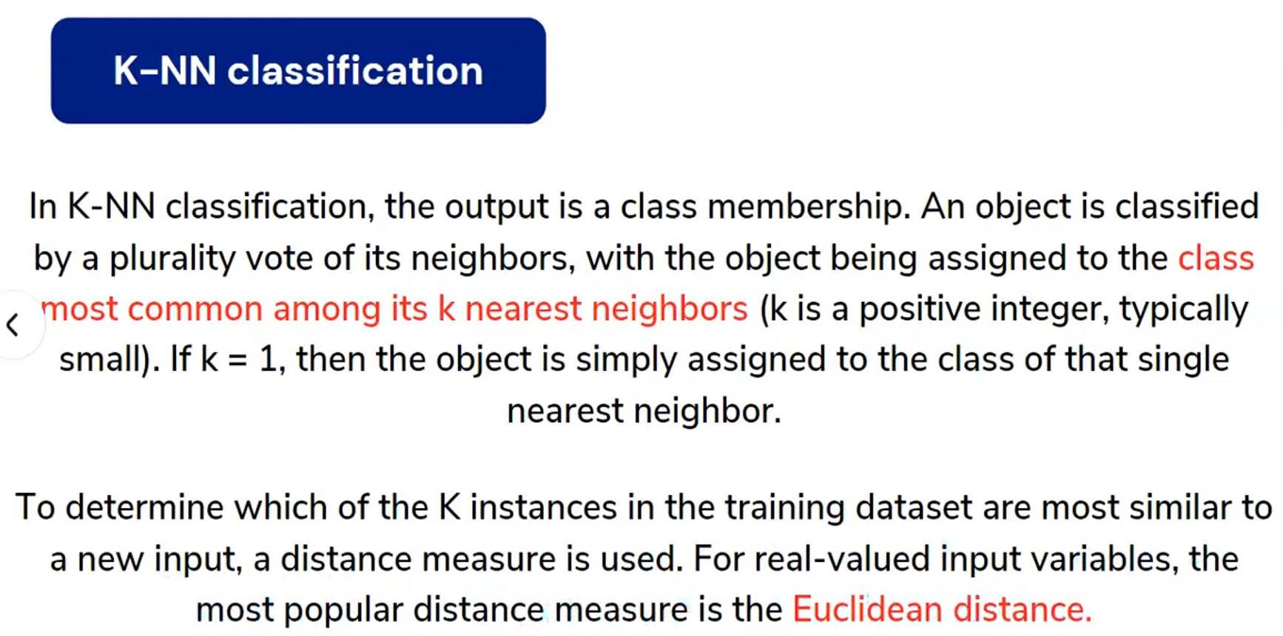

**Distance Metrics:**

* **Euclidean Distance:**

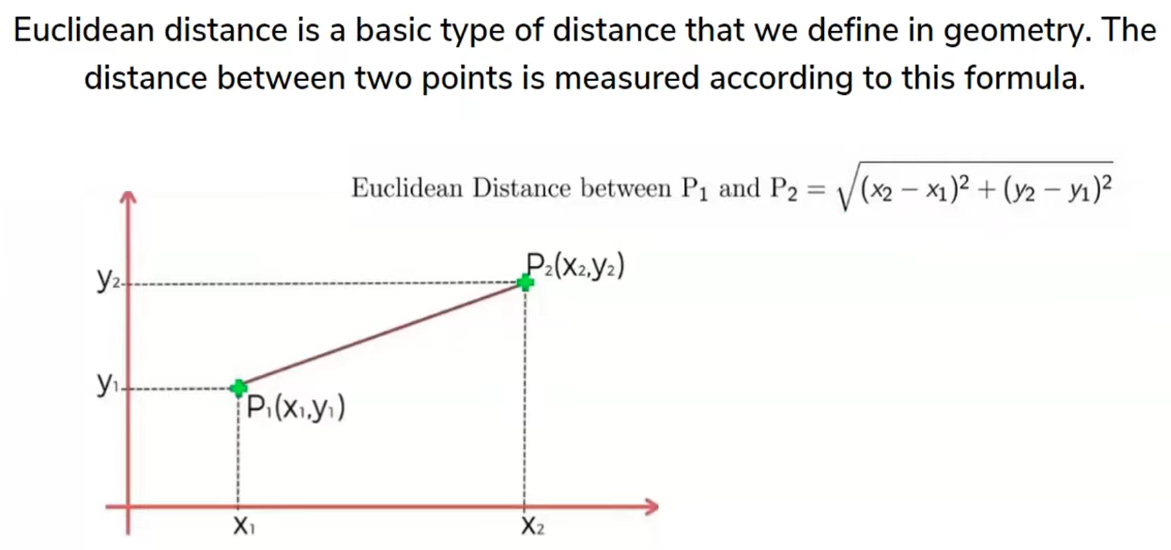

* **Manhattan Distance:**

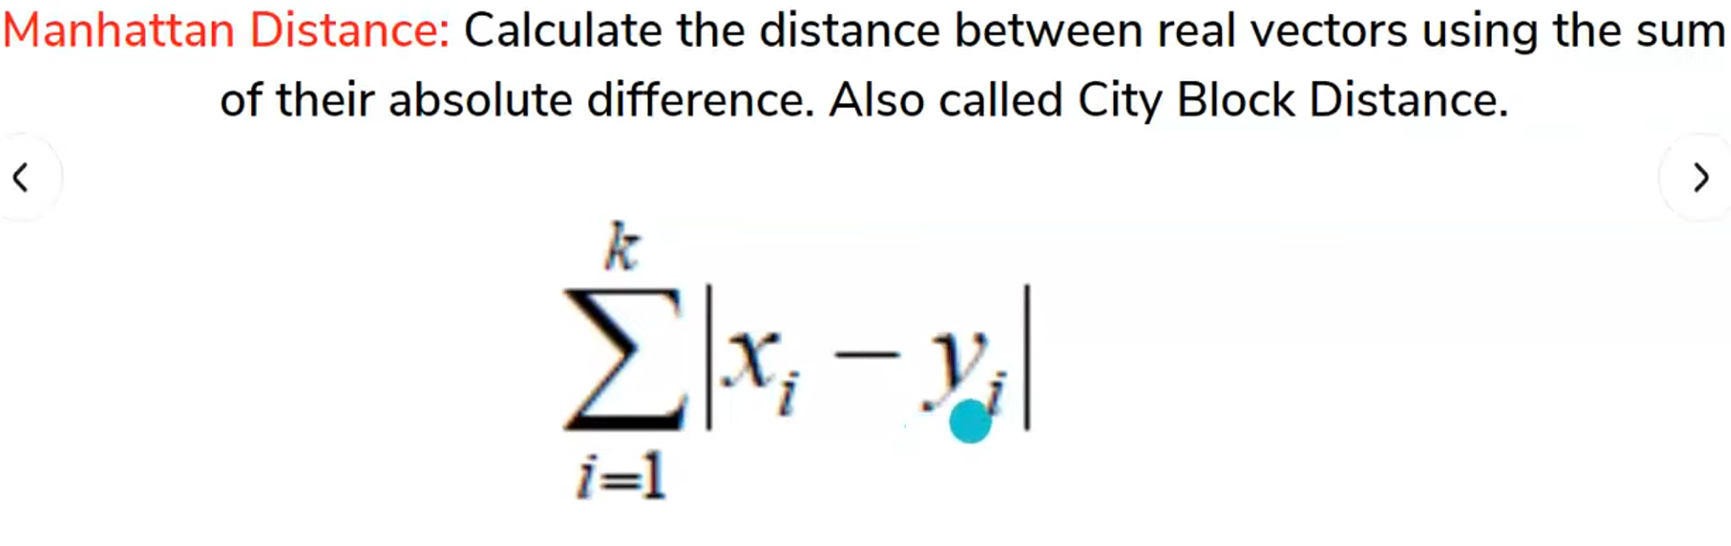

* **Minkowski Distance:**

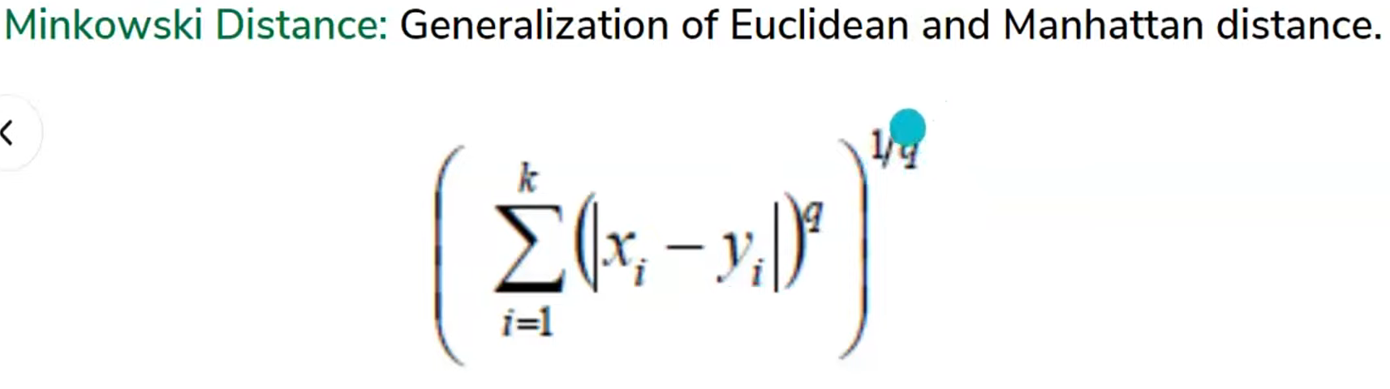

**Hamming Distance**

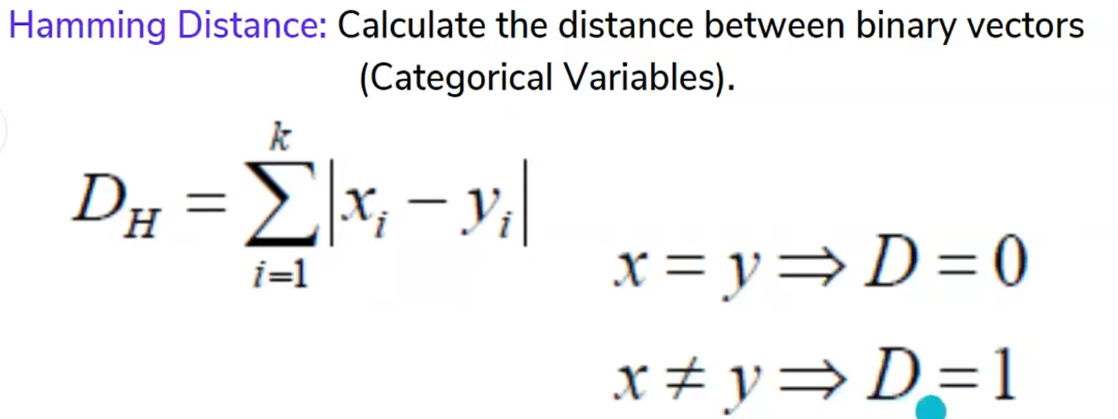

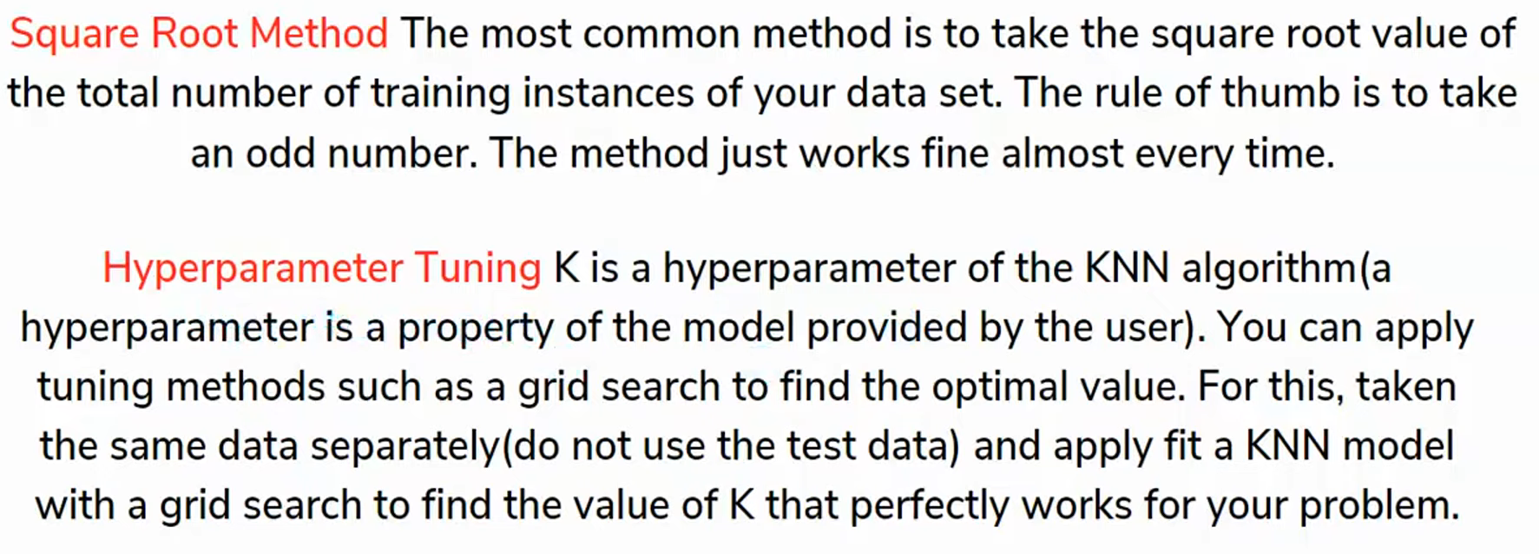

**Logistic Regression:**

* Suitable for binary classification problems.
* Produces a probability score for the prediction.
* Can be extended to multiclass classification using techniques like one-vs-rest or softmax regression.

**K-Nearest Neighbors:**

* Non-parametric and simple to implement.
* Works well with small datasets and low-dimensional data.
* Computationally expensive with large datasets and high-dimensional data.

Both logistic regression and KNN are essential classification algorithms used in various applications, each with its strengths and suitable scenarios.

### Support Vector Machine (SVM) Classification

**Concept:** Support Vector Machine (SVM) is a supervised machine learning algorithm used for classification tasks. It works by finding the optimal hyperplane that separates the data into different classes. In the case of two-dimensional data, this hyperplane is a line.

**Example:** Imagine you want to classify lemons as ripe or not ripe based on their size and color.

### SVM Formula and Key Concepts

* 1. **Hyperplane:** The decision boundary that separates the data into different classes. For linearly separable data, SVM finds the hyperplane that maximizes the margin between the two classes.

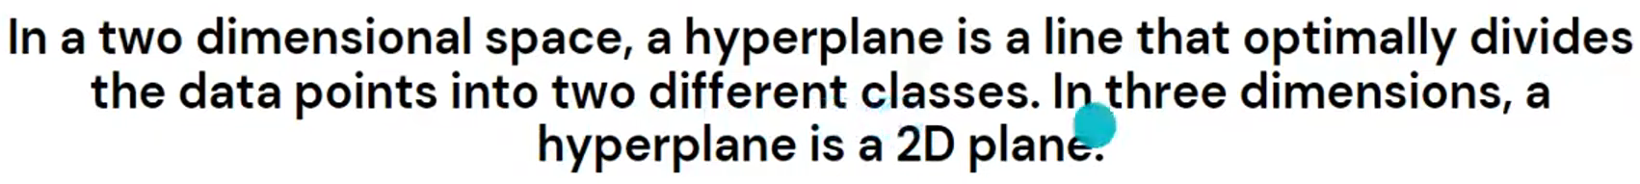

* 1. **Margin:** The distance between the hyperplane and the closest data points from each class. These closest points are called support vectors. The objective of SVM is to maximize this margin.

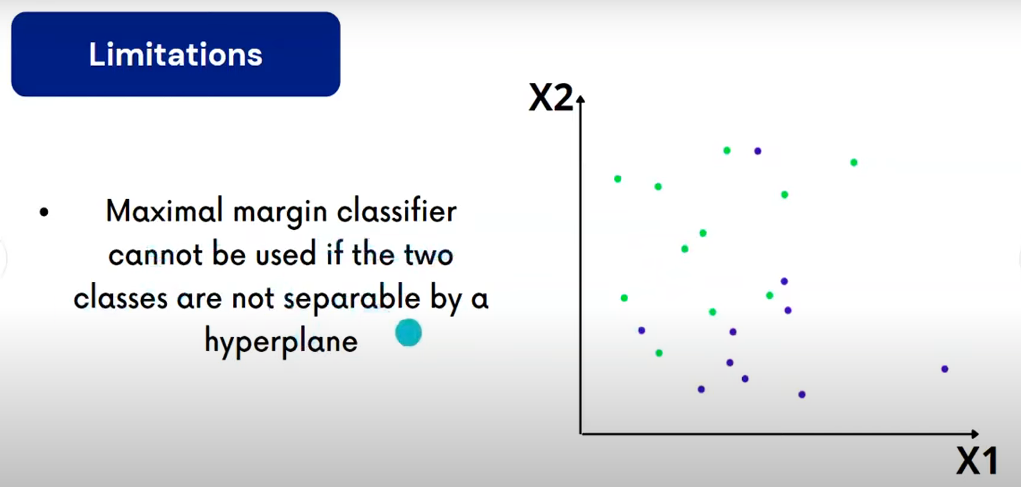

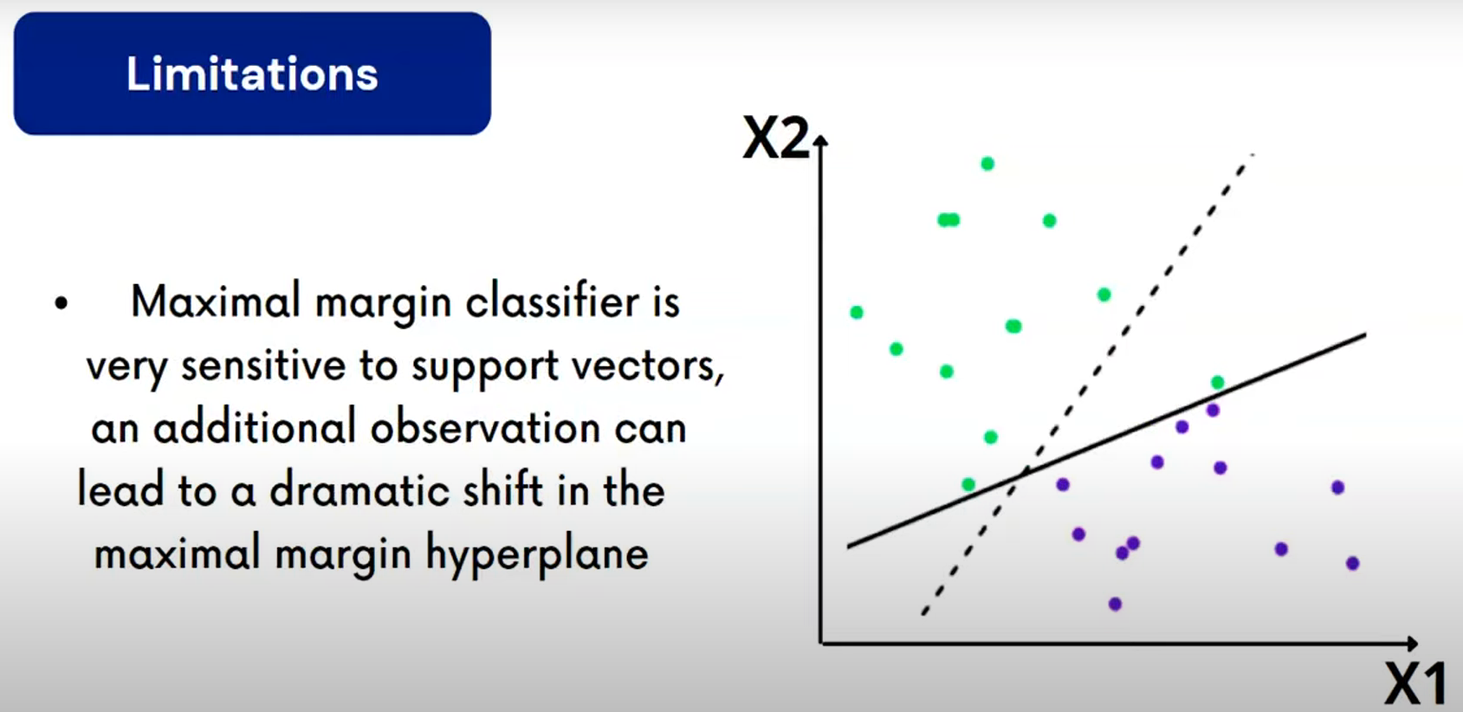

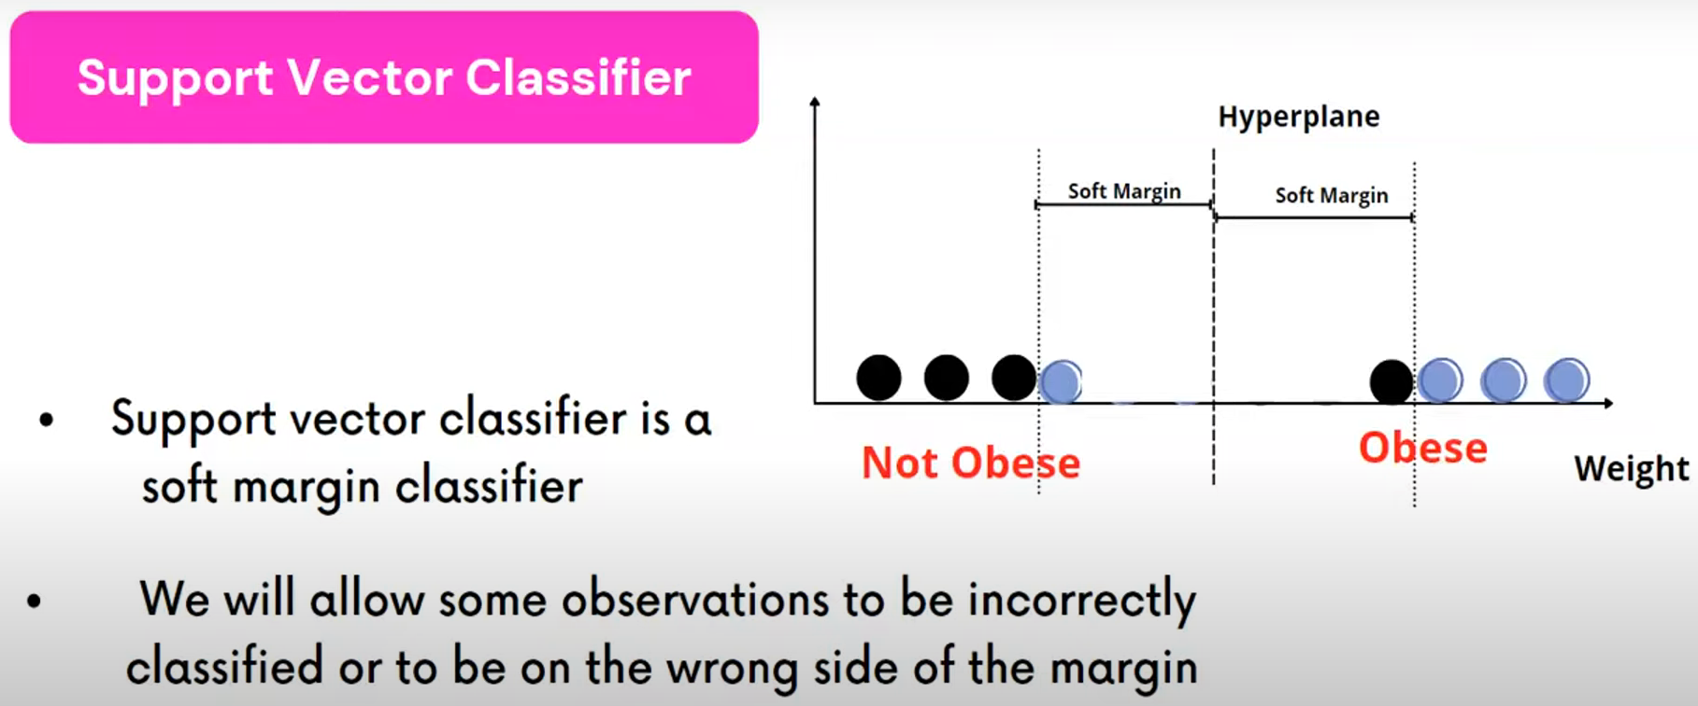

**Formula:**

**Objective:** Maximize the margin by solving the following optimization problem:

**3. Kernel Trick:** For non-linearly separable data, SVM uses kernel functions to transform the data into a higher-dimensional space where a linear hyperplane can separate the classes. Common kernel functions include:

* **Linear Kernel:**
* **Polynomial Kernel:**
* **Radial Basis Function (RBF) Kernel:**
* Etc

### Steps to Build an SVM Model

1. **Collect Data:** Gather data on the size and color of lemons and their ripeness.
2. **Choose Kernel:** Select an appropriate kernel function based on the data's linearity.
3. **Train the Model:** Use the collected data to find the optimal hyperplane that separates the classes.
4. **Make Predictions:** For a new lemon, determine its class based on which side of the hyperplane it falls on.

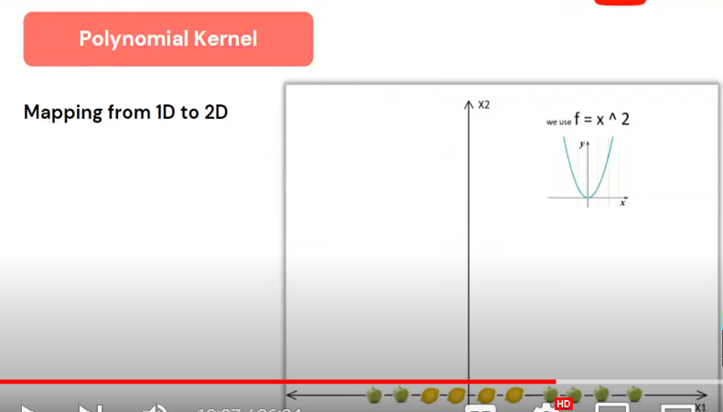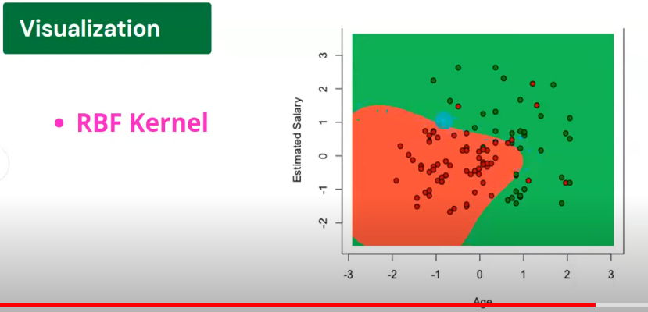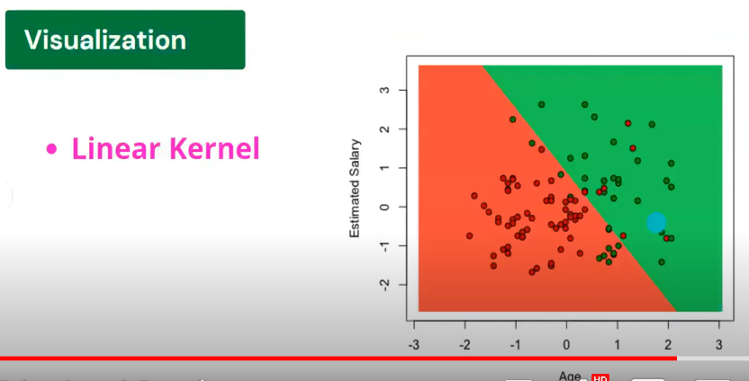

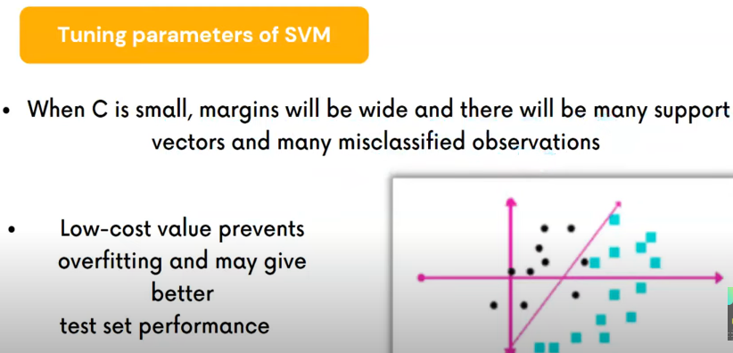

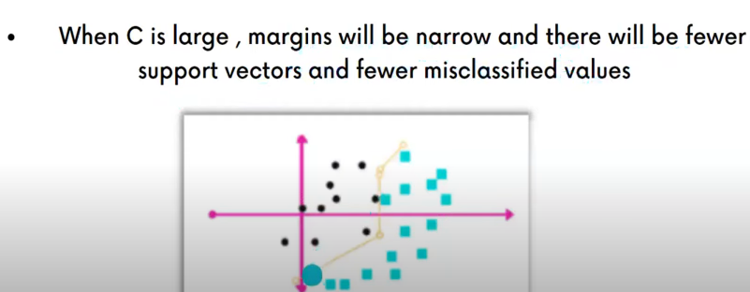

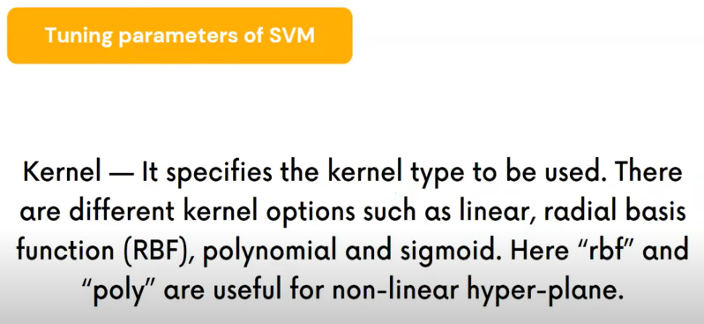

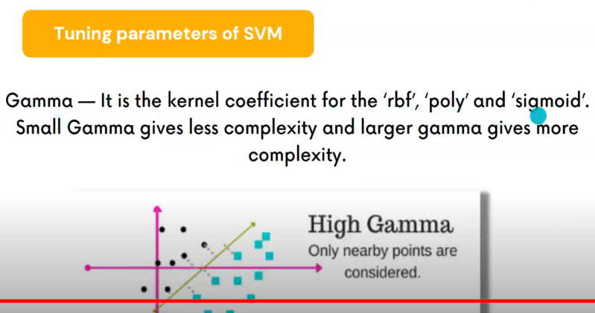

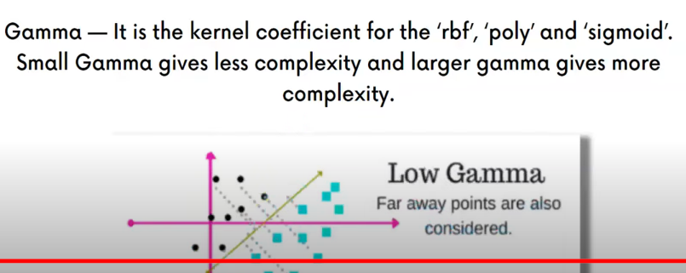

### Bayes' Theorem

Bayes' Theorem is a fundamental theorem in probability theory that provides a way to update the probability of a hypothesis based on new evidence. It combines our prior belief about an event with new evidence to give us an updated belief.

#### Bayes' Theorem Formula

#### 

#### Example: Medical Diagnosis

Let's use an example of a medical test to understand Bayes' Theorem.

1. **Problem Statement**:
   * You want to determine the probability that a person has a certain disease given that they tested positive for it.
2. **Known Probabilities**:

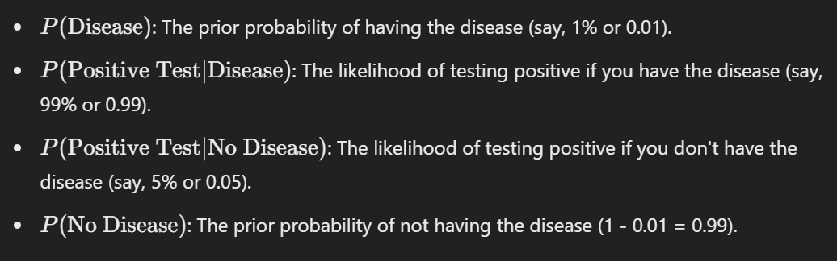

1. **Calculate the Marginal Probability**:

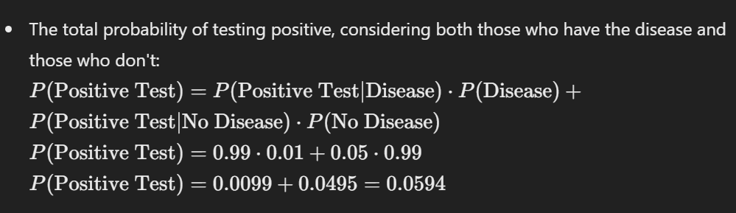

1. **Apply Bayes' Theorem**:

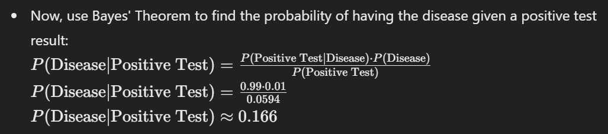

So, even if you tested positive, the probability of actually having the disease is around 16.6%. This shows how prior information and the reliability of the test play crucial roles in interpreting results.

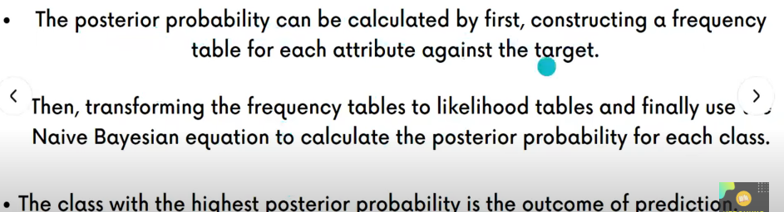

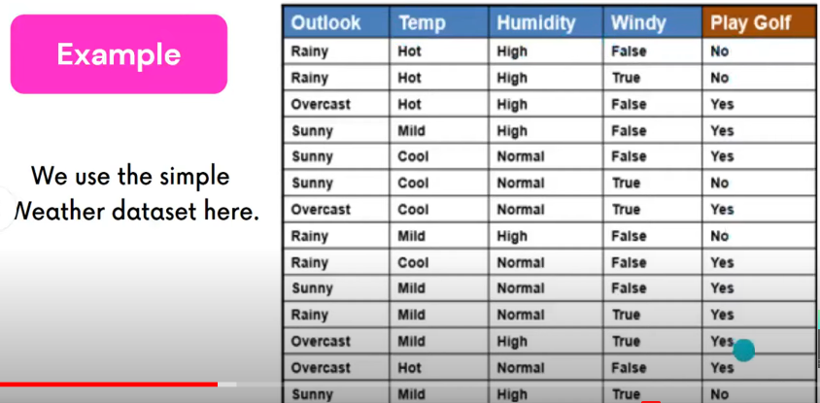

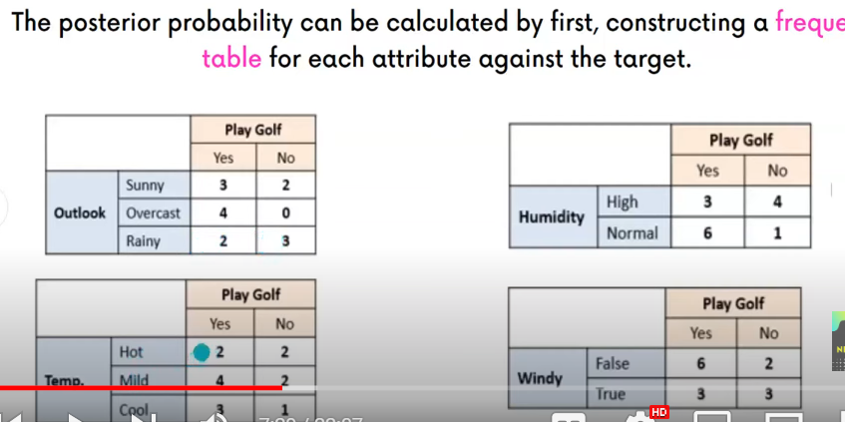

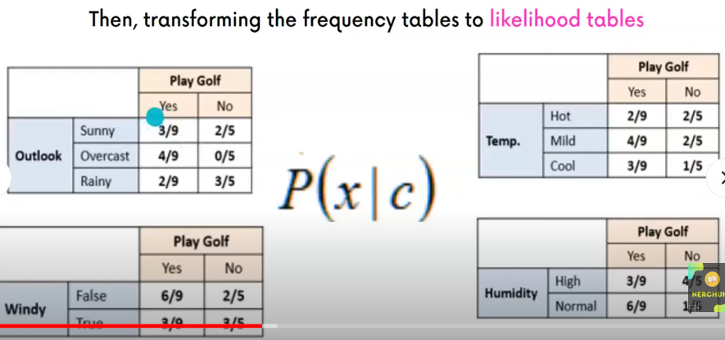

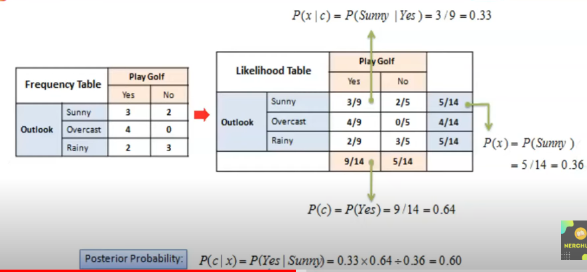

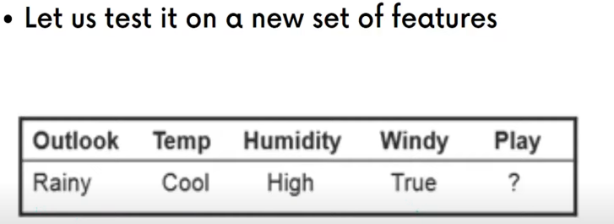

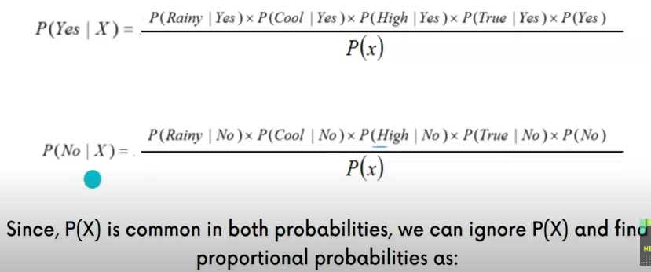

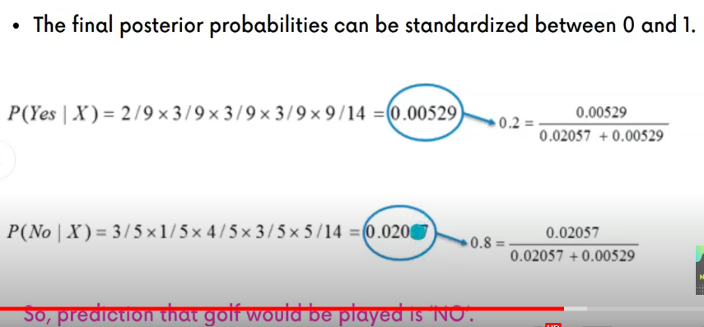

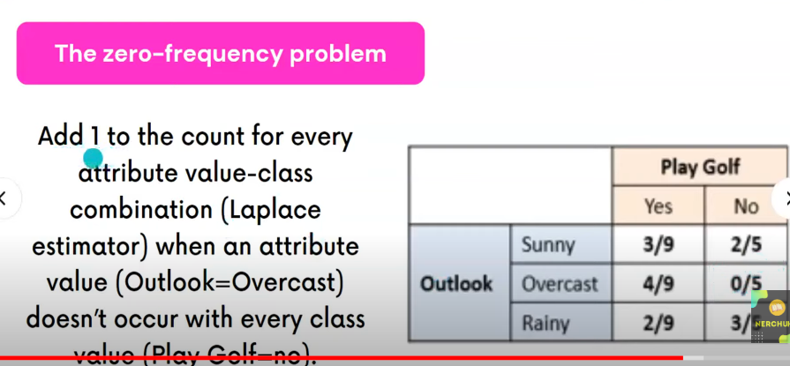

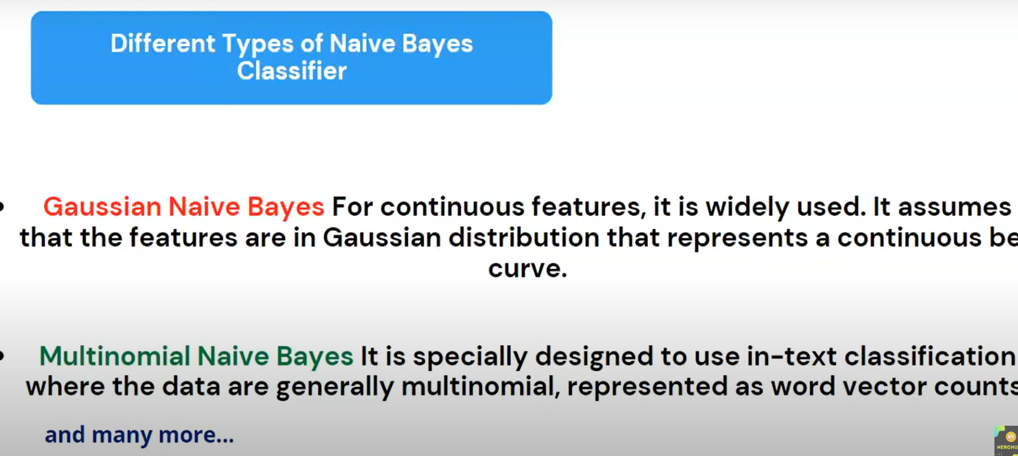

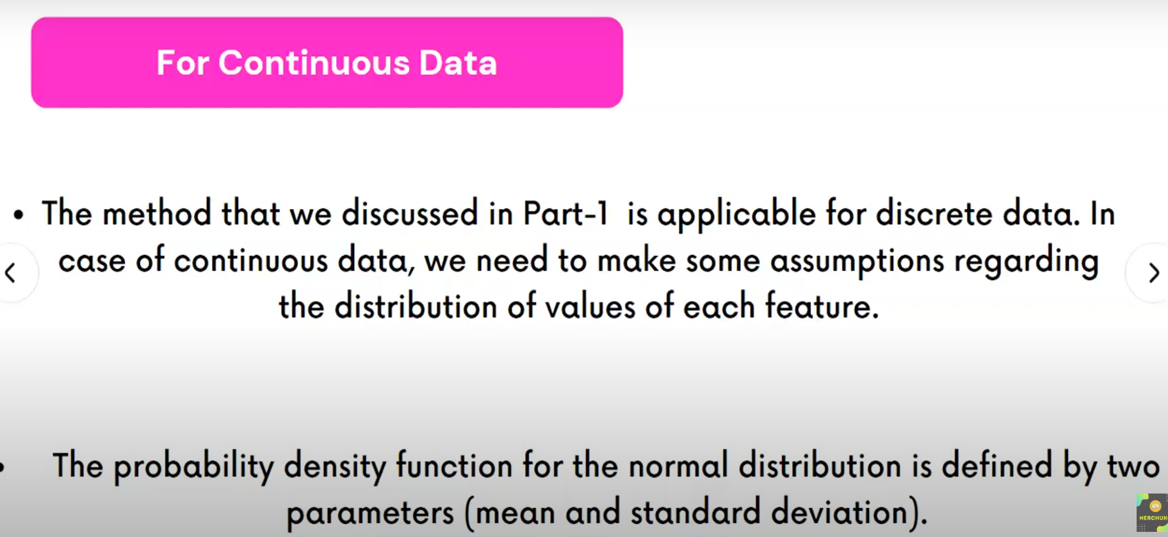

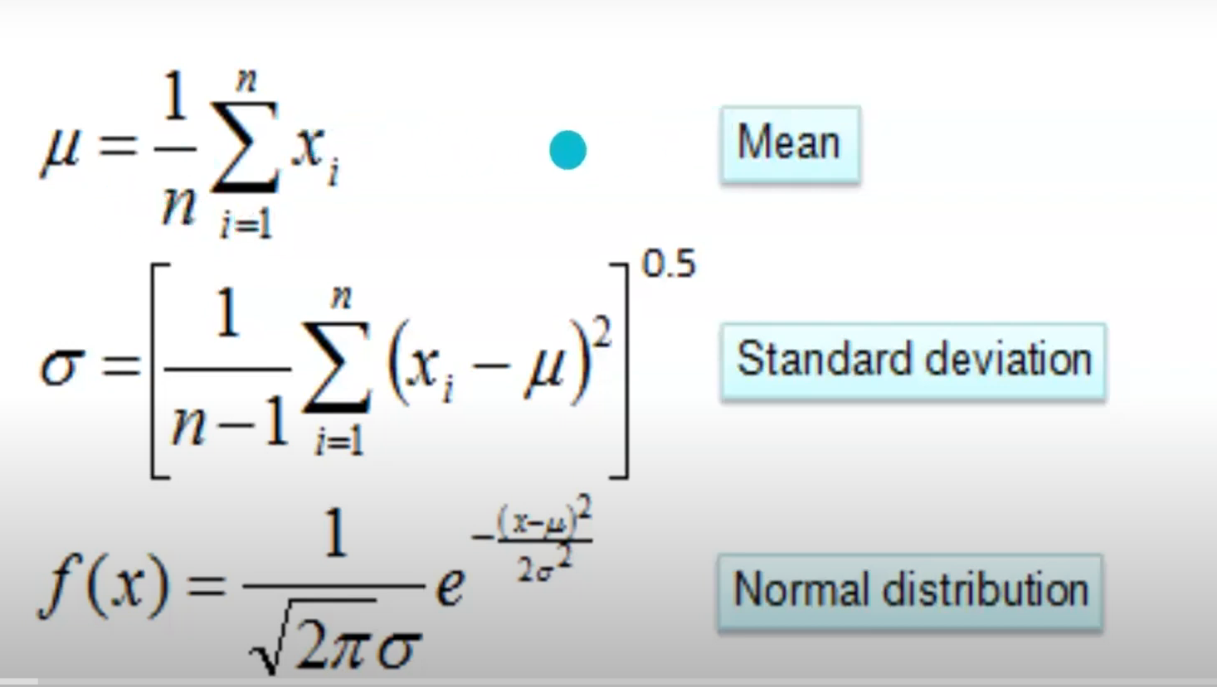

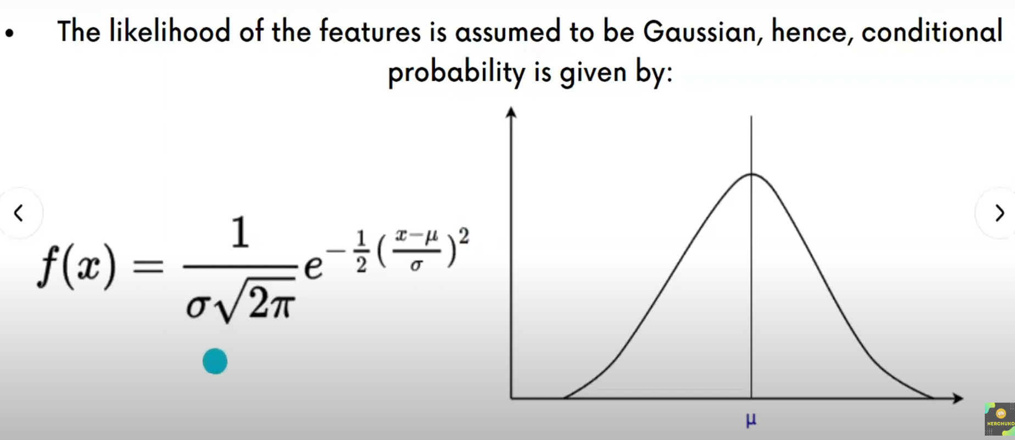

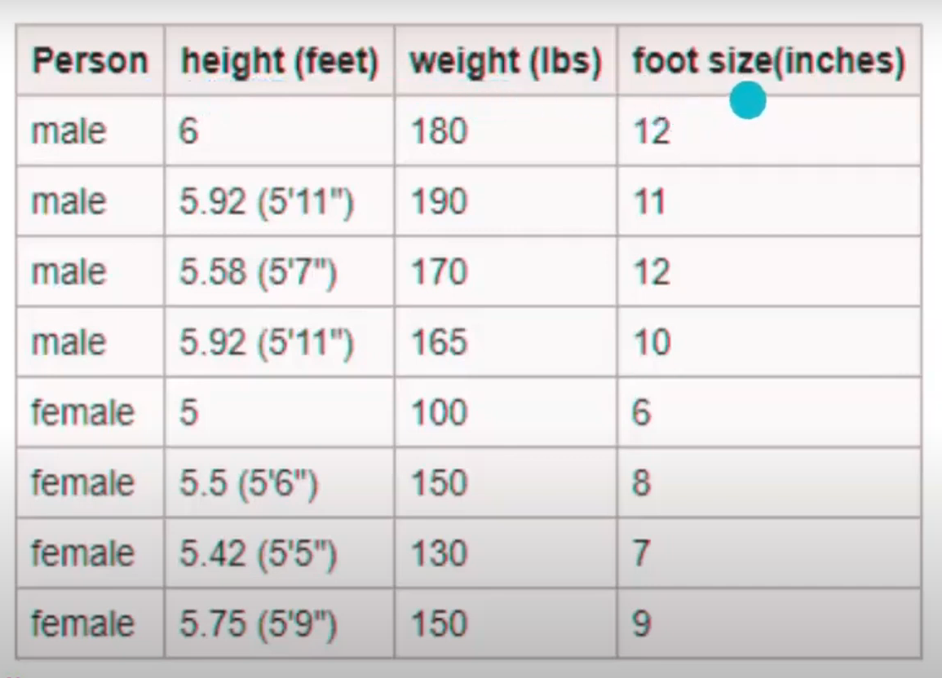

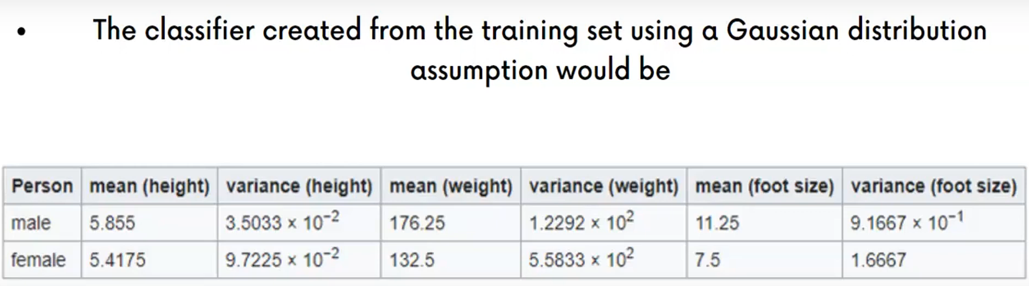

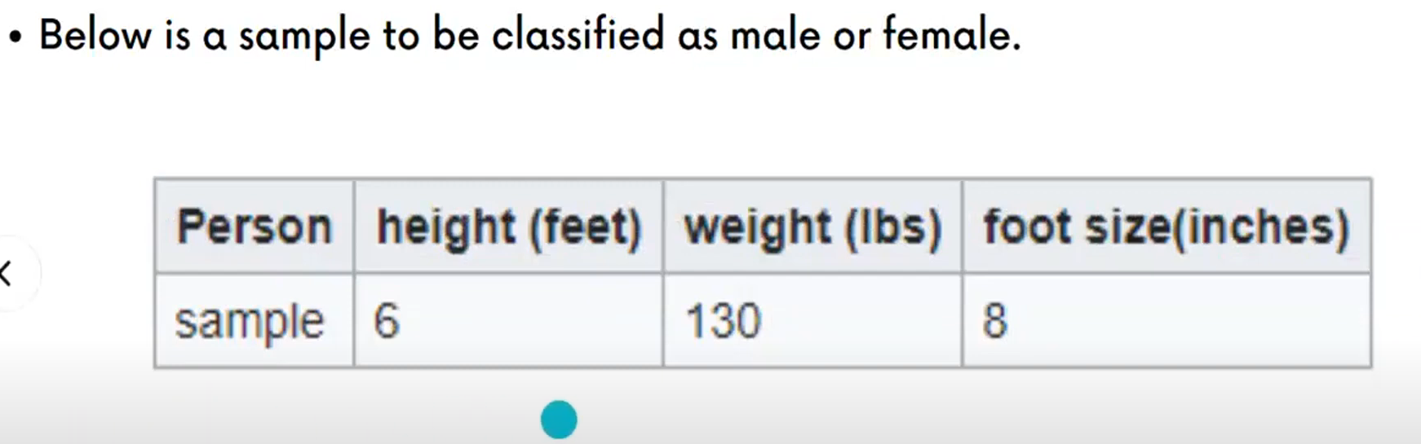

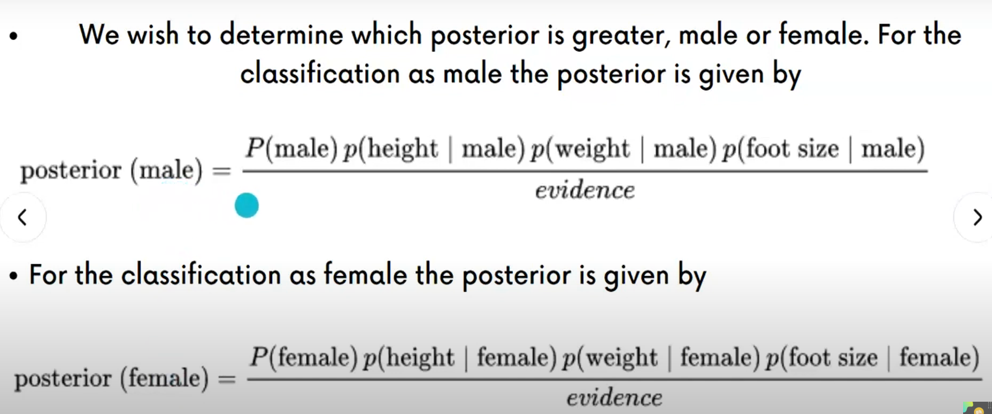

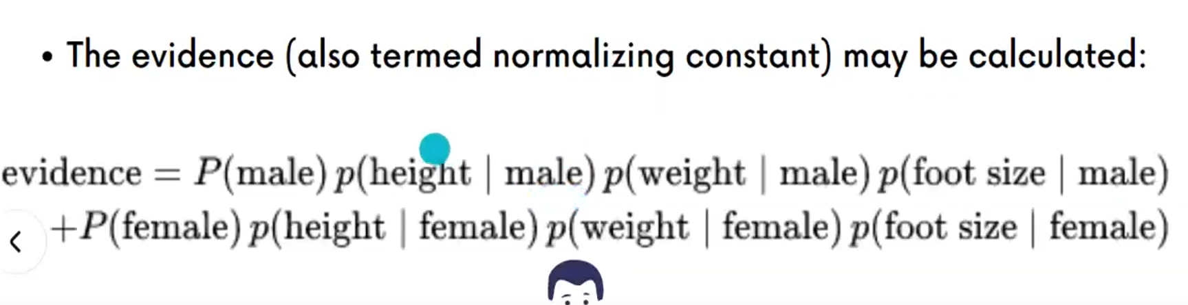

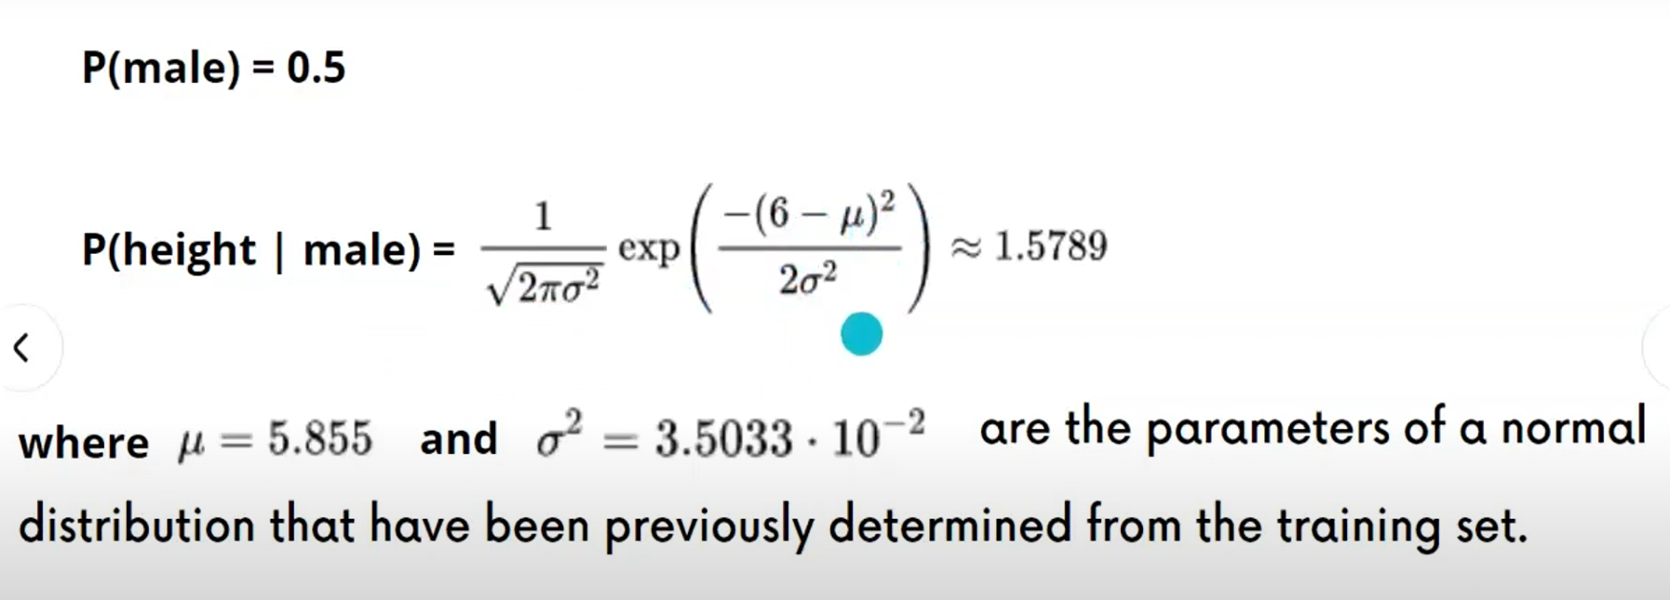

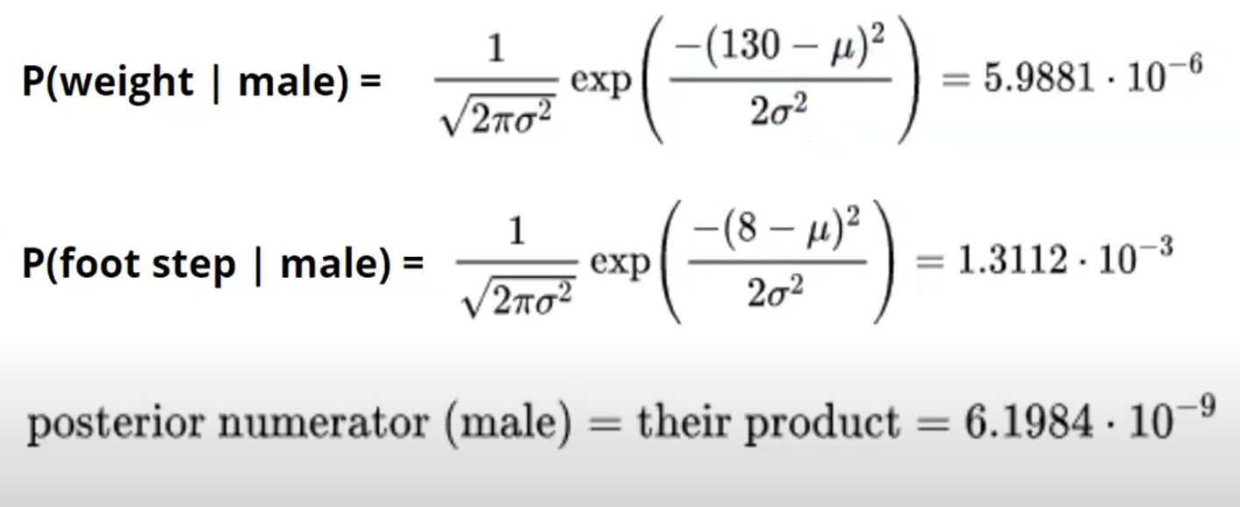

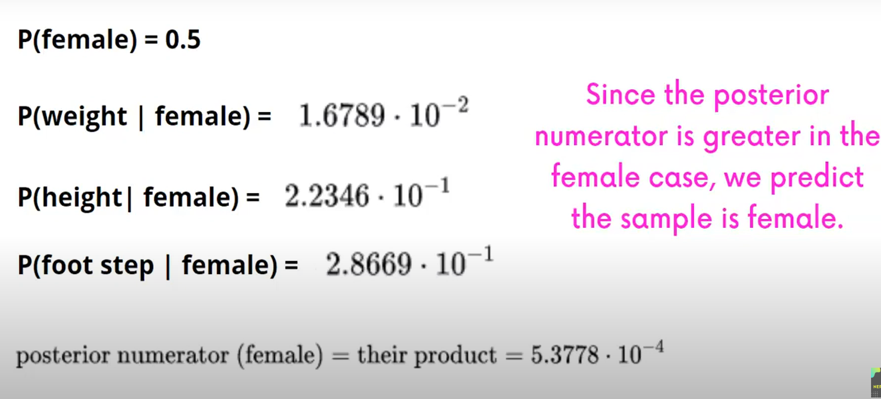

**Decision Tree:**

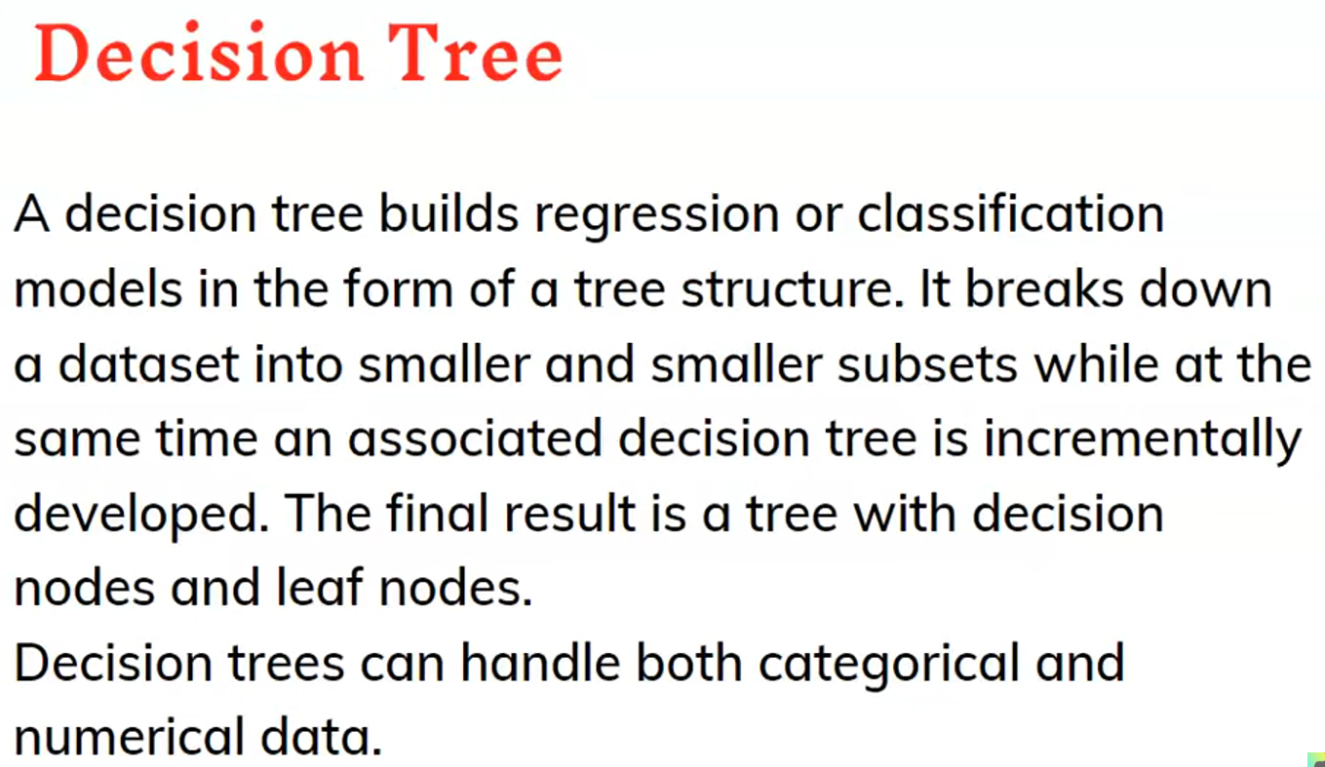

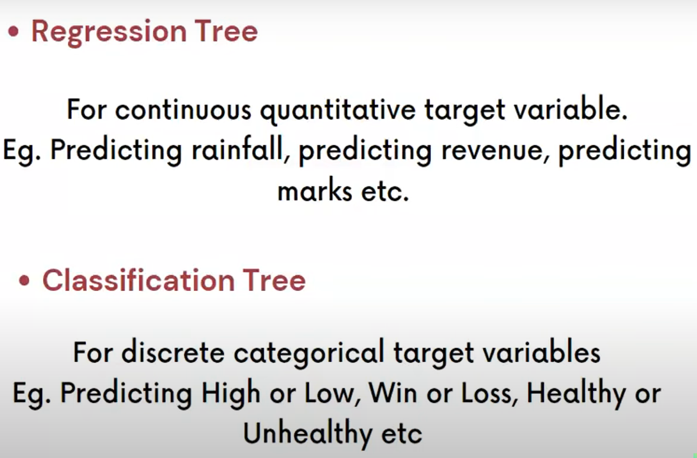

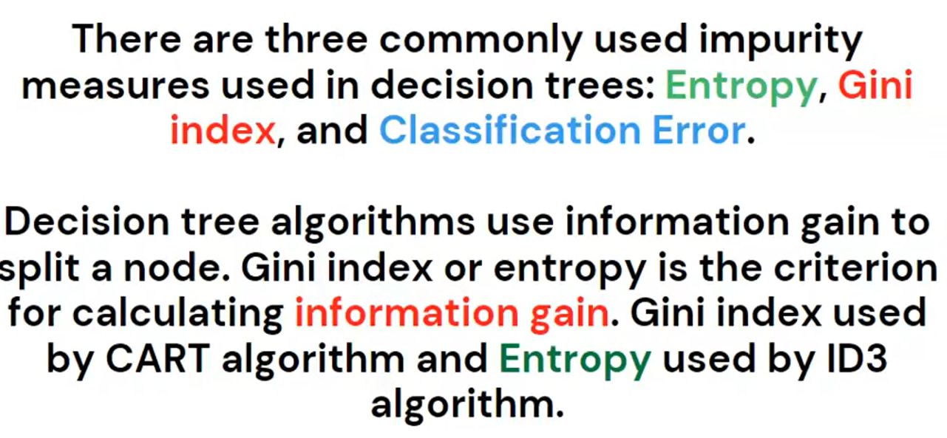

**What is impurity?**

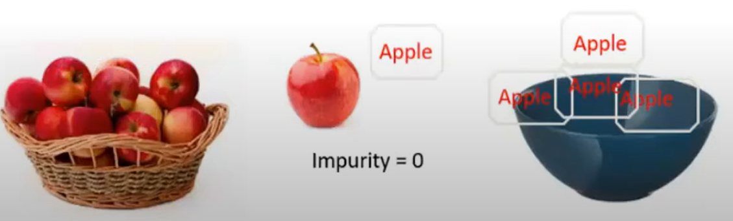

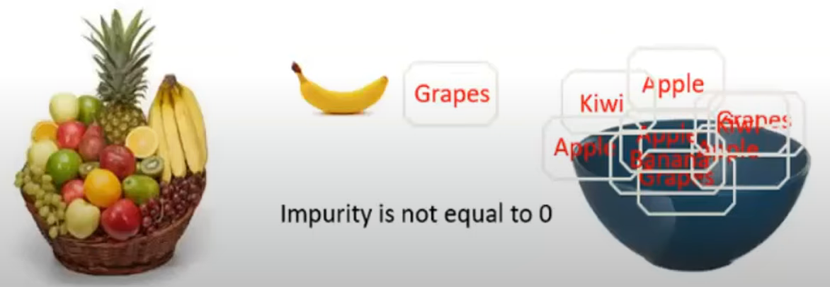

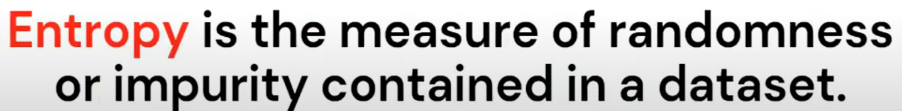

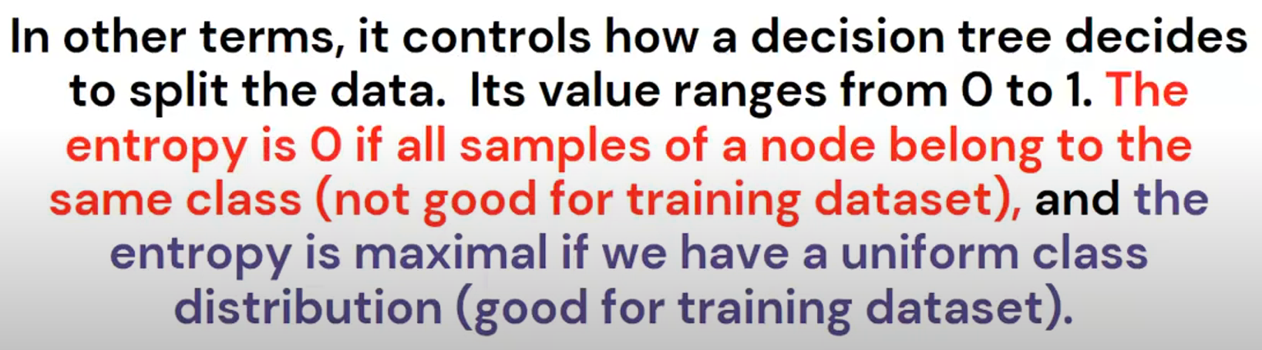

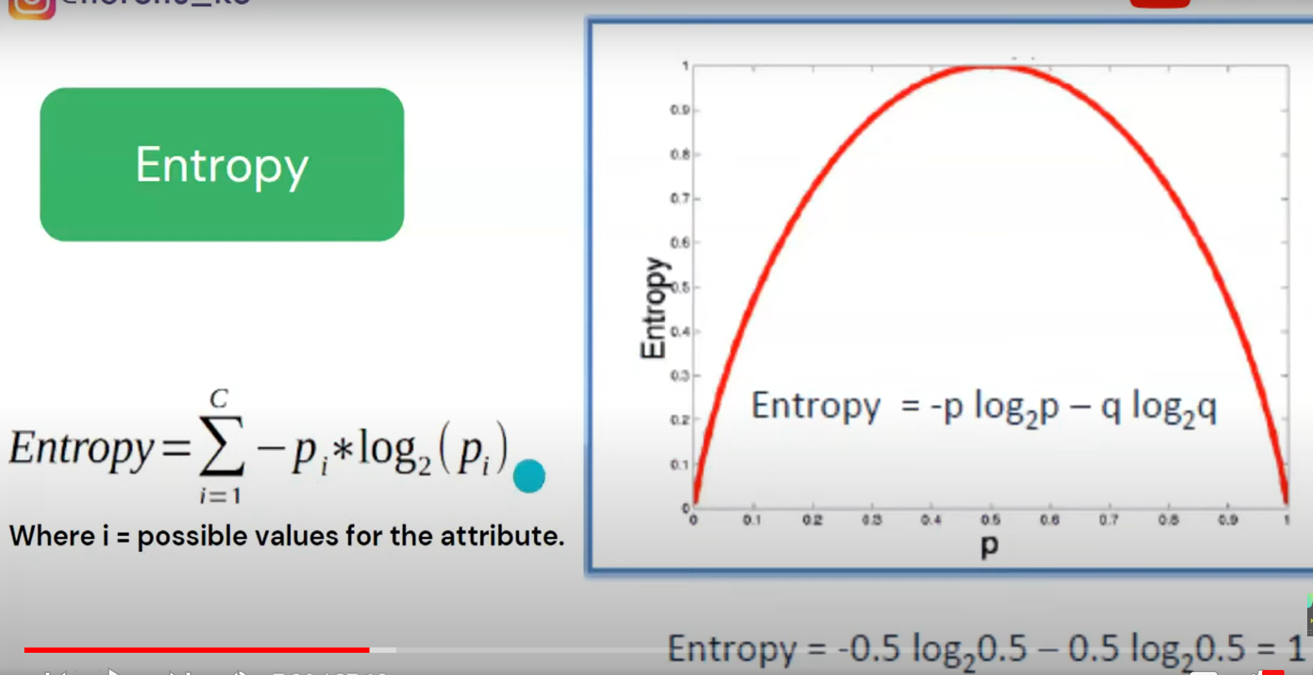

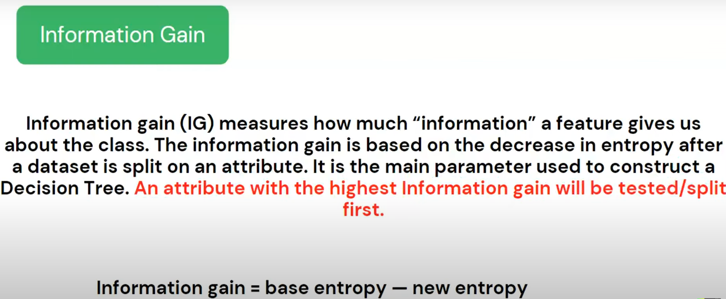

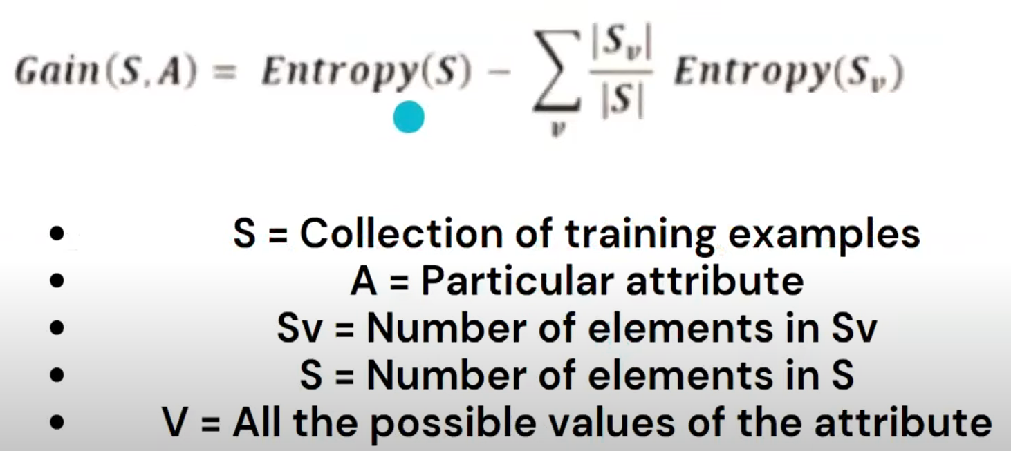

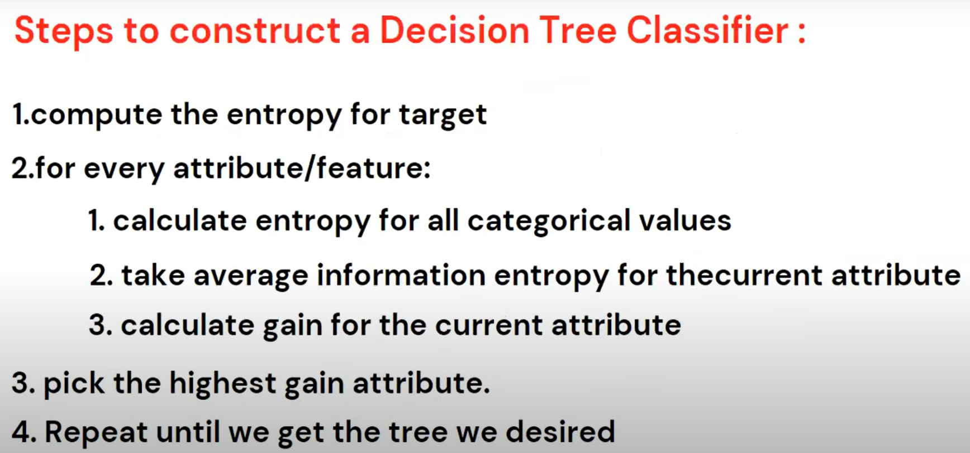

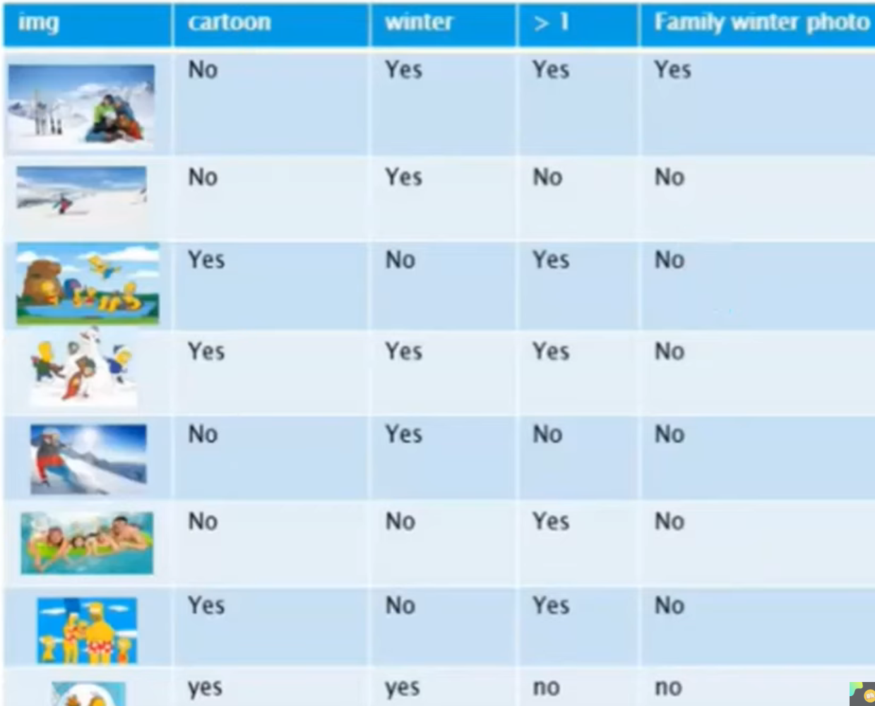

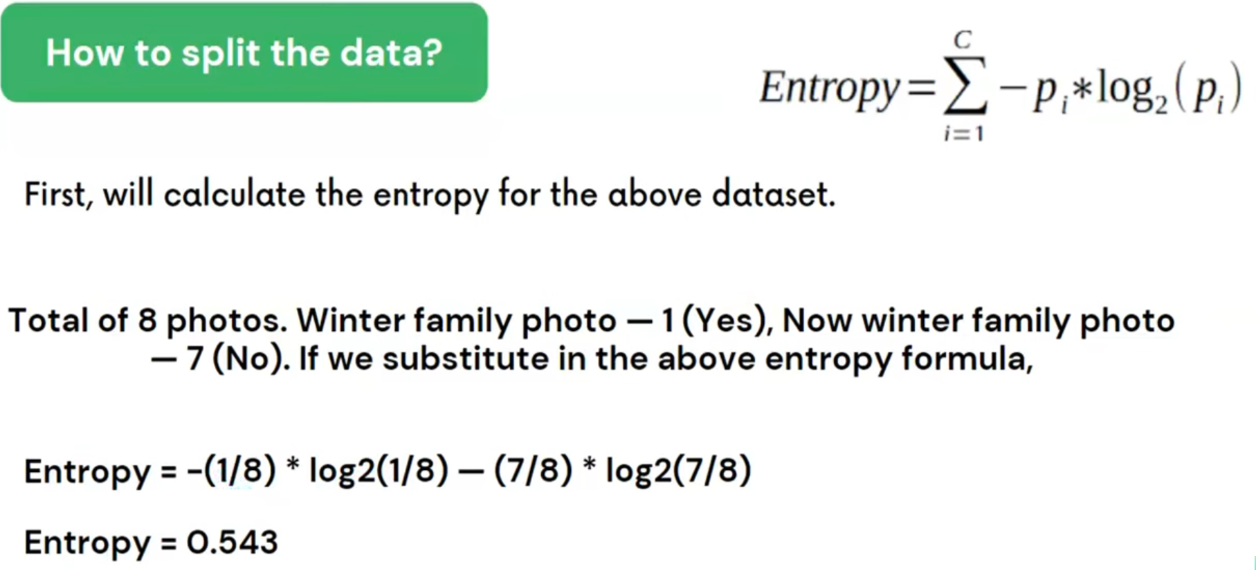

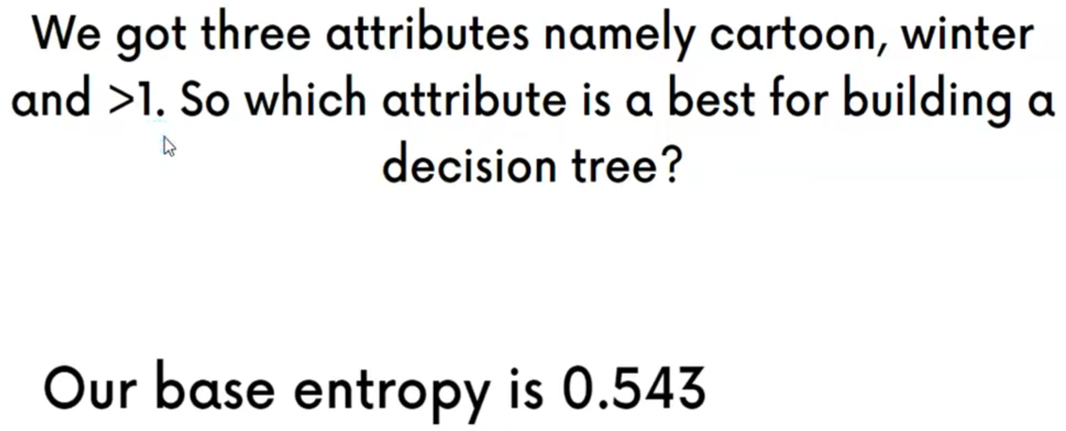

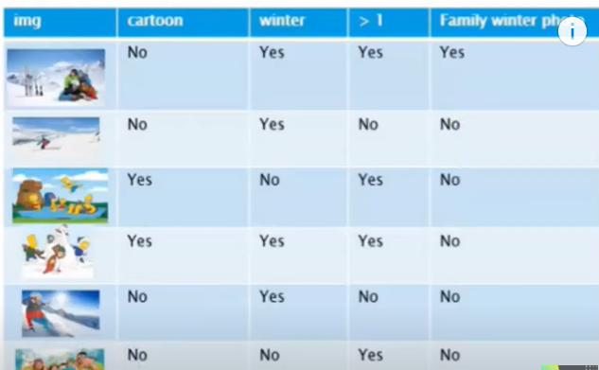

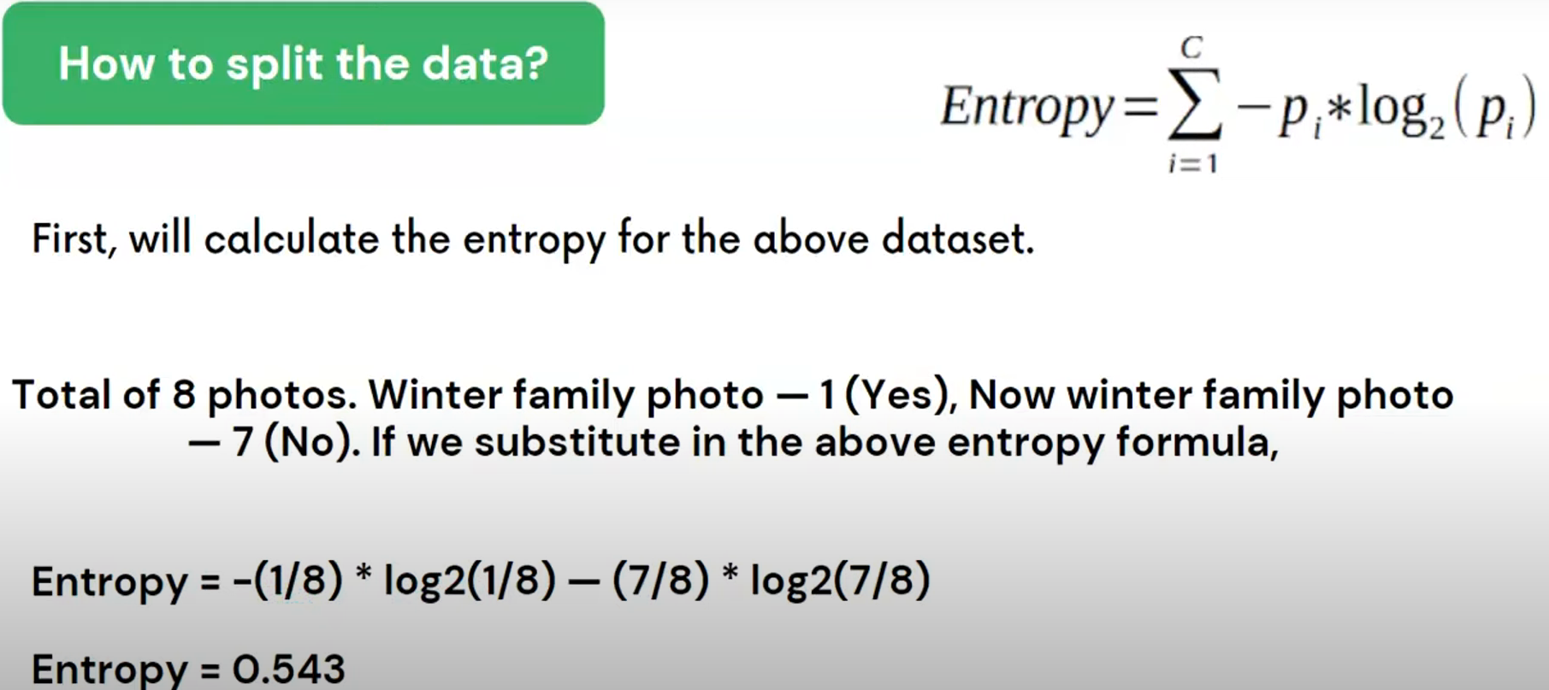

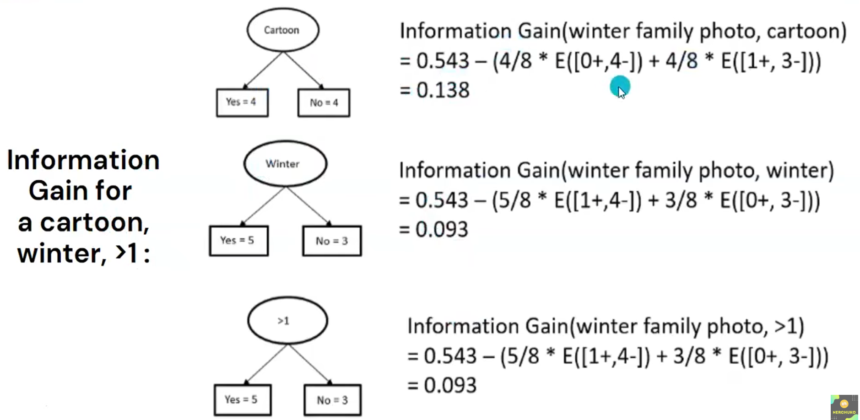

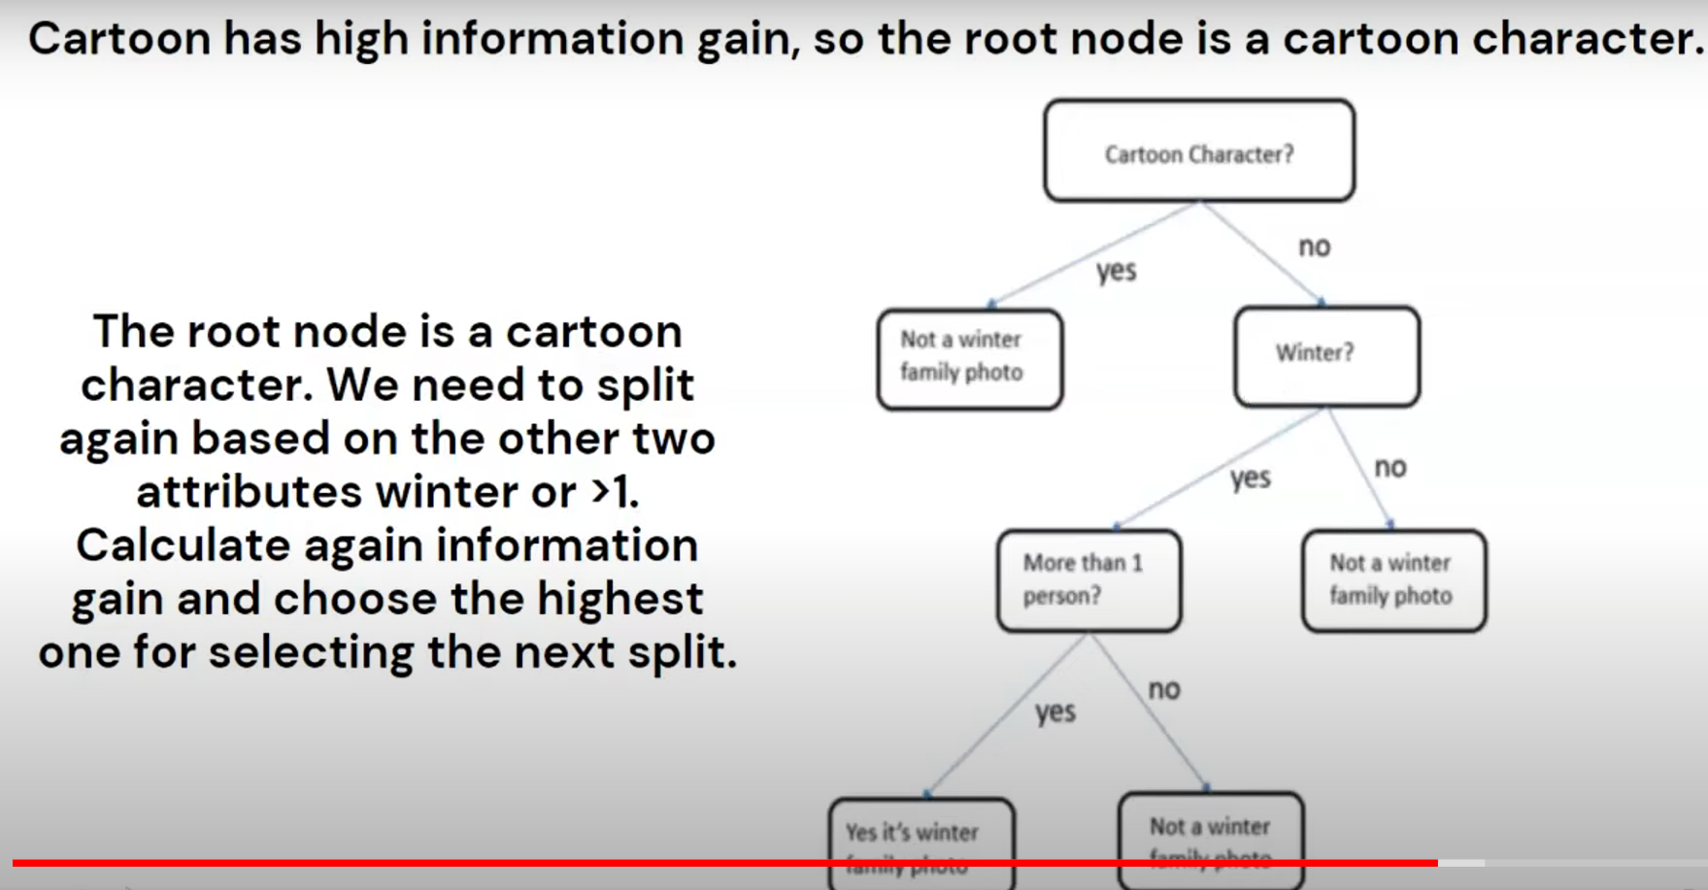

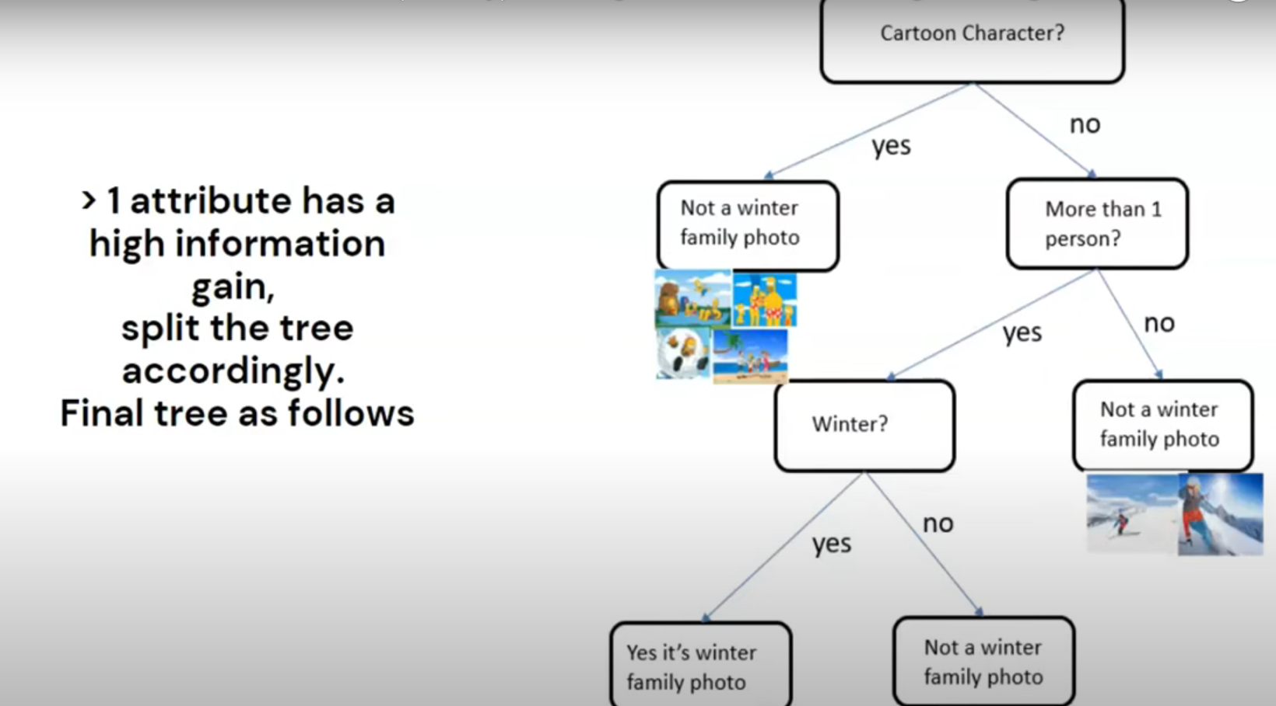

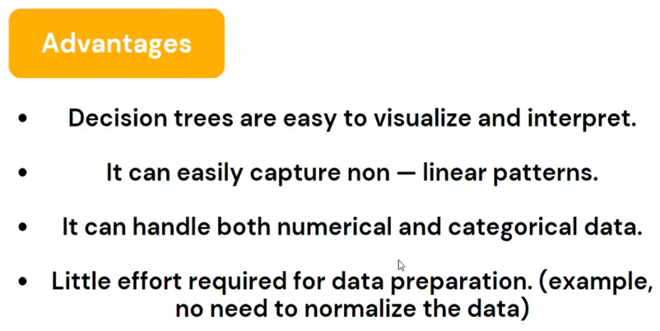

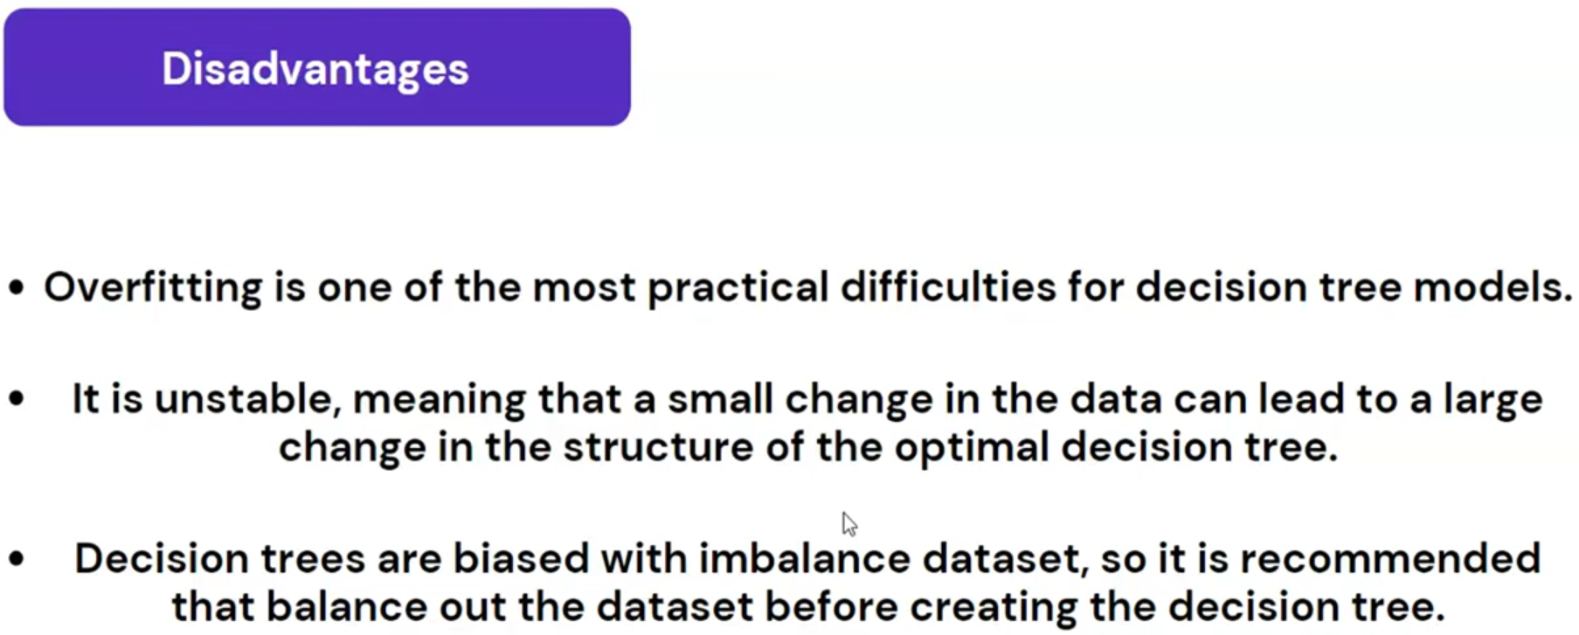

**RANDOM FOREST CLASSIFIER:**

